PUNE VIDYARTHI GRIHA’s
COLLEGE OF ENGINEERING AND TECHNOLOGY
&

G K PATE (WANI) INSTITUTE OF MANAGEMENT, PUNE – 411009


DEPARTMENT OF MBA

PVG’s COET & GKPIM, PUNE-9 SAVITRIBAI PHULE PUNE UNIVERSITY


FIELD PROJECT REPORT
ON

‘A STUDY OF WORKING CAPITAL MANAGEMENT WITH REFERENCE TO AARADHYA ENTERPRISES, PUNE’
SPECIALIZATION - FINANCE

SUBMITTED BY SAKSHI ARUN SARDE

Class - FYMBA 2ND SEMESTER MARCH 2025

DEPARTMENT OF MBA

PUNE VIDYARTHI GRIHA’s

COLLEGE OF ENGINEERING AND TECHNOLOGY
&

G K PATE (WANI) INSTITUTE OF MANAGEMENT, PUNE – 411 009

CERTIFICATE

This is to certify that the “FIELD PROJECT REPORT” submitted by SAKSHI ARUN SARDE, CRN NO. 24019012, is work done by her and submitted during 2024 - 2025 academic year, in partial fulfilment of the requirements for the First Year Course in MBA,
Pune Vidyarthi Griha’s College of Engineering & Technology and G K Pate (Wani) Institute of Management, Pune – 411 009

Prof. Suyog Shinde Prof. Samradnyee Mehendale Subject teacher Project Guide

ACKNOWLEDGEMENT

I take this opportunity to express my sincere gratitude to all those who have supported me throughout the completion of this project titled "A Study of Working Capital Management with Reference to Aaradhya Enterprises, Pune."
First and foremost, I would like to extend my heartfelt thanks to Aaradhya Enterprises, Pune, for giving me the opportunity to undertake this study and providing me with the necessary support and resources. I am truly grateful to the management and staff for their cooperation and valuable insights which were instrumental in the successful completion of this project.

I wish to express my deep sense of gratitude to my project guide Prof. Samradnyee Mehendale, whose guidance, encouragement, and constructive suggestions helped me throughout the study. Their constant support and expertise were vital in shaping the direction and content of this research.

I would also like to thank our respected Dr. Smita Temgire, HOD of MBA, for providing a conducive learning environment and for encouraging academic pursuits.

A special thanks to all my faculty members and friends who supported me directly or indirectly during the project work. Their motivation and help at various stages were invaluable.

Lastly, I would like to thank my family for their unwavering support, encouragement, and patience during this entire journey.

Sakshi Arun Sarde MBA First Year
Pune Vidyarthi Griha’s
College of Engineering and Technology
& G K Pate (Wani) Institute of Management

DECLARATION

I, Sakshi Arun Sarde, a student of MBA First Year, at Pune Vidyarthi Griha’s
College of Engineering and Technology & G K Pate (Wani) Institute of Management, hereby declare that the project titled "A Study of Working Capital Management with Reference to Aaradhya Enterprises, Pune" has been carried out by me as part of the academic requirement for the completion of my course.

I also declare that this project is the result of my own efforts and has not been submitted to any other university or institution for the award of any degree, diploma, or certificate.

The information provided in this project is true to the best of my knowledge and belief. Any assistance or contribution received during the course of this project has been duly acknowledged.

Place: Pune

Date:

Name: Sakshi Arun Sarde
CRN Number: 24019012

Signature

ABSTRACT

Working Capital is required for carrying out day to day business operations. The present day competitive market environment calls for an efficient management of working capital. Proper management of working capital is essential to a company’s fundamental financial health and operational success as a business. A hallmark of good business management is the ability to utilize working capital management to maintain a solid balance between growth, profitability and liquidity.

The Field Project titled ‘A Study of Working Capital Management in Aaradhya Enterprises’ aims to study the various aspects of Working Capital Management.
This study is based on Aaradhya Enterprises Pune, which is a providing services, sales to customer, AMC (Annual Maintenance Contract) to contract customer.

The period considered for the study is five years i.e. from Financial year 2019-2020 to 2023-24.
The research methodology adopted for this study is secondary source of data which include annual reports, other proprietary reports and primary source of data which include owner interview of Aaradhya Enterprises.

This project tries to evaluate how the management of working capital is done in Aaradhya Enterprises through Intra Firm Ratio Analysis and Comparative Statement Analysis. The study of working capital management has shown that Aaradhya Enterprises has a fairly strong working capital position. The Company is also enjoying reasonable profits.

TABLE OF CONTENTS

Sr. No. | Particulars | Page No.
1. | Introduction  - Introduction  - Statement of the Problem  - Purpose /Objectives of the Project  - Theoretical Framework  - Significance of the Project | 9-22
2. | Review of the Literature  Review the existing body of knowledge available on the problem or topic | 23-28
3. | Method  Describes how the study was completed / conducted, including a specific description of subjects, procedures, equipment, materials, and other information pertinent to the study | 29-33
4. | Data Collection and Analysis  - Collecting relevant data from primary and secondary sources  - Analysing data using appropriate analytical tools and techniques | 34-56
5. | Results / Finding & Suggestions  - Identifying key issues, opportunities, trends etc. based on data analysis  - Develop / propose feasible solutions or recommendations  - Reflect on the experience, lessons learned, and scope for further work / improvement | 57-62
6. | Conclusion | 63
7. | Annexure | 64-74

List of Tables

Sr. No. | Particulars | Page No.
1. | Current Ratio | 36
2. | Quick Ratio | 37
3. | Working Capital Turnover Ratio | 41
4. | Inventory Turnover Ratio | 42
5. | Trade Receivables Turnover Ratio | 44
6. | Trade Payables Turnover Ratio | 46
7. | Net Operating Cycle | 48
8. | Gross Profit Ratio | 49
9. | Net Profit Ratio | 50

List of Figure

Sr. No. | Particulars | Page No.
1. | Classification of Working Capital | 9
2. | Operating Cycle of business | 13
3. | Current Ratio | 36
4. | Quick Ratio | 37
5. | Comparison of Current Assets & Current Liabilities | 38
6. | Inventory | 39
7. | Trade Receivables | 44
8. | Trade Payables | 46
9. | Cash & Cash Equivalents | 41
10. | Working Capital Turnover Ratio | 41
11. | Inventory Turnover Ratio | 42
12. | Inventory Holding Period | 44
13. | Trade Receivables Turnover Ratio | 44
14. | Average Collection Period | 46
15. | Trade Payables Turnover Ratio | 46
16. | Average Payment Period | 47
17. | Net Operating Cycle | 48
18. | Gross Profit Ratio | 49
19. | Net Profit Ratio | 50

CHAPTER 1. INTRODUCTION

Introduction

    - WORKING CAPITAL MANAGEMENT

CONCEPT OF WORKING CAPITAL MANAGEMENT
Financial management can be divided into two broad areas of responsibility as the management of long-term capital and the management of short-term funds or working capital. Working capital means the funds available and used for day-to-day operations of an enterprise. It consists broadly of that portion of assets of a business which are used in or related to its current operations. Efficient management of working capital is an essential pre–requisite for the successful operation of a business enterprise and improving its rate of return on the capital invested in short-term assets.
The components of Working Capital Management are as follows:
        - Cash Management
        - Inventory Management
        - Receivables Management
        - Payables Management

TYPES OF WORKING CAPITAL
According to the needs of business, the working capital may be classified as follows:

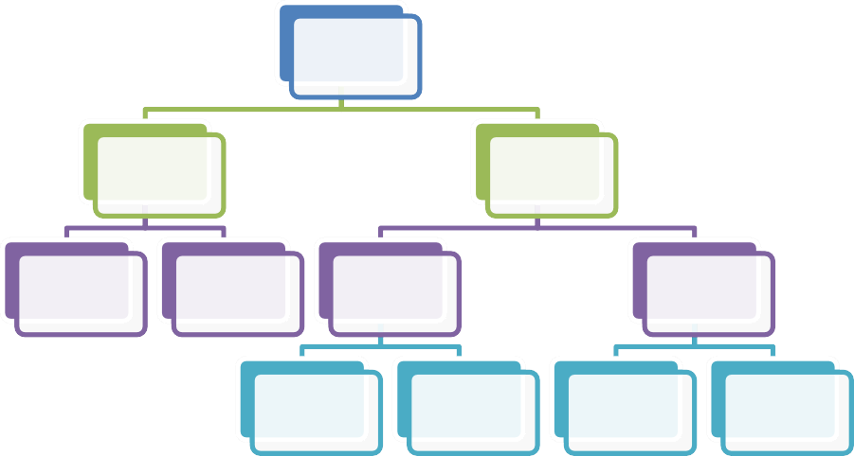
WORKING
CAPITAL
BASIS OF
CONCEPT
BASIS OF TIME
GROSS
WORKING CAPITAL
NET WORKING
CAPITA L
PERMANENT
WORKING CAPITAL
VARIABLE
WORKING CAPITAL
RESERVE
MARGIN
CAPITAL
REGULAR
WORKING
CAPITAL
SEASONAL
WORKING
CAPITAL
SPECIAL
WORKING
CAPITAL

Classification of Working Capital

- ON THE BASIS OF PERIODICITY:
On the basis of periodicity working capital can be divided under two categories as under:
  - Permanent working capital: This refers to that minimum amount of investment in all current assets which is required at all times to carry out minimum level of business activities.
This has referred to this type of working capital as —Core current assets. Fixed working capital can further be divided into two categories as under:
    - Regular Working capital: Minimum amount of working capital required to keep the primary circulation. Some amount of cash is necessary for the payment of wages, salaries etc.
    - Reserve Margin Working capital: Additional working capital may also be required for contingencies that may arise any time. The reserve working capital is the excess of capital over the needs of the regular working capital is kept aside as reserve for contingencies, such as strike, business depression etc.

  - Variable or Temporary Working Capital: The amount of such working capital keeps on fluctuating from time to time on the basis of business activities. In other words, it represents additional current assets required at different times during the operating year. For example, extra inventory has to be maintained to support sales during peak sales period. The variable working capital may also be subdivided into following two sub-groups:
    - Seasonal Variable Working capital: Seasonal working capital is the additional amount which is required during the active business seasons of the year. Raw materials like raw-cotton or jute or sugarcane are purchased in particular season. The industry has to borrow funds for short period. It is particularly suited to a business of a seasonal nature. In short, seasonal working capital is required to meet the seasonal liquidity of the business.
    - Special variable working capital: Additional working capital may also be needed to provide additional current assets to meet the unexpected events or special operations such as extensive marketing campaigns or carrying of special job etc.

- ON THE BASIS OF CONCEPT:
On the basis of concept working capital is divided into two categories as under:

  - Gross Working Capital: Gross working capital refers to total investment in current assets. The current assets employed in business give the idea about the utilization of working capital and idea about the economic position of the company. Gross working capital concept is popular and acceptable concept in the field of finance.
  - Net Working Capital: Net working capital means current assets minus current liabilities. The difference between current assets and current liabilities is called the net working capital. If the net working capital is positive, business is able to meet its current liabilities. Net working capital concept provides the measurement for determining the creditworthiness of company.

FACTORS DETERMINING WORKING CAPITAL
The following factors determine the requirement of working capital :
- Nature of Companies: Needs for working capital are determined by the nature of an enterprise. Small companies have smaller proportions of cash, receivables and inventory than large corporation. This difference becomes more marked in large corporations. A public utility, for example, mostly employs fixed assets in its operations, while a merchandising department depends generally on inventory and receivable.

- Nature and Size of Business: The working capital requirements of a firm are basically influenced by the nature of its business. Trading and financial firms have a very less investment in fixed assets, but require a large sum of money to be invested in working capital. Retail stores, for example, must carry large stocks of a variety of goods to satisfy the varied and continues demand of their customers.

- Time: The level of working capital depends upon the time required to manufacturing goods. If the time is longer, the size of working capital is great. Moreover, the amount of working capital depends upon inventory turnover and the unit cost of the goods that are sold.

- Volume of Sales: This is the most important factor affecting the size and components of working capital. The volume of sales and the size of the working capital are directly related to each other. As the volume of sales increase, there is an increase in the investment of working capital-in the cost of operations, in inventories and receivables.

- Terms of Purchases and Sales: If the credit terms of purchases are more favourable and those of sales liberal, less cash will be invested in inventory. With more favourable credit terms, working capital requirements can be reduced.

- Business Cycle: Business expands during periods of prosperity and declines during the period of depression. Consequently, more working capital required during periods of prosperity and less during the periods of depression.

- Liquidity and Profitability: If it is interested in improving its liquidity, it can increase the level of its working capital. However, this policy is likely to result in a reduction of the sales volume, and therefore, profitability. A firm should choose between liquidity and profitability and decide about its working capital requirements accordingly.

COMPONENTS OF WORKING CAPITAL MANAGEMENT

- CASH MANAGEMENT
Cash management is one of the most important areas in the day-to-day management of the firm‘s deals with the management of working capital, which is defined as all the short term assets used in daily operations. This consists primarily of cash, marketable securities, accounts receivable and inventory. The balances in these accounts can be highly volatile as they respond very quickly to changes in the firm‘s operating environment. Healthy circulation of cash in the entire business operation is the basis of business solvency. Ultimately every transaction in a business results 12 either in an inflow or an outflow of cash. There should be sufficient cash with a firm all the time to meet the needs of the business. If the cash balance with a firm at any time is surplus or deficit, it is obvious that the finances are mismanaged. Cash Management needs strategies to deal with various facets of cash. Following are some of its facets.

INVENTORY MANAGEMENT
Inventory constitutes an important item in the working capital of many business concerns. Inventory is a major item of current assets. The term inventory refers to the stocks of the product of a firm is offering for sale and the components that make up the product Inventory is stores of goods and stocks. This includes raw materials, work-in-process and finished goods. Raw materials consist of those units or input which are used to manufactured goods that require further processing to become finished goods. Finished goods are products ready for sale. The classification of inventories and the levels of the components vary from organisation to organisation depending upon the nature of business.

RECEIVABLES MANAGEMENT
Management of Receivables refers to planning and controlling of debt owed to the firm from customer on account of credit sales. When large amounts of money is tied up in receivables, there are chances of bad debts. On the contrary, if the investment in receivables is low, the sales may be low since competitors offer liberal terms. Therefore, management of receivables require proper policies and their implementation.
There are basically three aspects of receivables management:
  - Credit Policy
  - Credit Analysis
  - Control of Receivables

PAYABLES MANAGEMENT
A considerable segment of procurement of products and services in a company are on credit conditions to a certain extent. Account Payables Management refers to the set of policies, procedures, and practices employed by a company with respect to managing its trade credit purchases. They consist of seeking trade credit lines, acquiring favorable terms of purchase, and managing the flow and timing of purchases so as to efficiently control the company’s working capital.

WORKING CAPITAL CYCLE
Every business organisation needs adequate working capital because the conversion of cash into finished goods to debtors and back to cash is not instantaneous. The continuing flow from cash to suppliers, to inventory, to accounts receivable and back into cash is called the working capital cycle or operating cycle. In other words, the term operating cycle refers to the length of time which begins with the acquisition of raw materials of a firm and ends with the final realisation of cash from debtors. The amount of working capital depends upon the length of working capital cycle. Longer the working cycle, higher is the need of working capital to be maintained. This is because the fund will then remain tied-up in various items of current assets for a longer period. The length of operating cycle varies from industry to industry and from business to business.
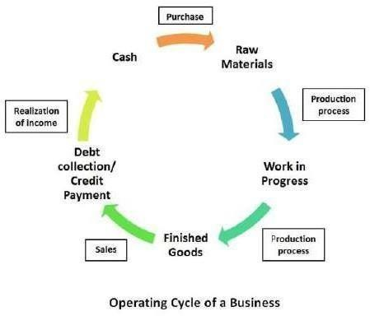

Statement of The Problem

Efficient working capital management is crucial for ensuring smooth business operations and maintaining financial stability, especially for small and medium enterprises (SMEs). Aaradhya Enterprises, like many other SMEs, operates in a competitive and dynamic environment where managing short-term assets and liabilities effectively can significantly influence its profitability and sustainability.

Despite the importance of working capital, many enterprises face challenges in optimizing components such as inventory, receivables, and payables. Moreover, the lack of structured analysis, such as intra-firm ratio analysis and a detailed examination of the operating cycle, can lead to inefficiencies in financial management.

This study seeks to evaluate how effectively Aaradhya Enterprises manages its working capital, with specific focus on intra-firm ratio analysis and the operating cycle. The goal is to identify gaps in current practices and propose actionable strategies to enhance financial performance and liquidity management.

Objective of The Study
- To understand the concept of Working Capital Management
- To study the component of Working Capital Management
- To analyze the efficiency of Working Capital Management in Aaradhya Enterprises using Intra Firm Ratio Analysis.
- To Examine the operating cycle of Aaradhya Enterprises, Pune.

Theoretical Framework
One of the most important area in the day-to-day management of the firm is the management of working capital. Working capital management is the functional area of finance that covers all the current assets of the firm. It is concerned with management of the level of individual current assets as well as the management of total working capital.
Working capital comes into business operation when actual operation takes place. Generally, the requirements of quantum of working capital is determined by the level of production which depends upon the management attitude towards risk and the factors which influence the amount of cash, inventories receivable and other current assets required to support given volume of production.

Meaning:
Working capital refers to that part of total capital which is used for carrying out the regular business operations. It is the amount of funds used for financing the day-to-day operations. In short it is the capital with which the business is worked over. Working capital means it is the excess amount of current assets over current liabilities.

Definitions:

According to Shubin:
“Working capital is the amount of funds necessary to cover the cost of operating the enterprise”.

According to Gerstenberg:
“Circulating capital means current assets of a company that are changed in the ordinary course of business from one form to another, as for example from cash to inventories, inventories to receivables, receivables to cash”.

According to Prof. H. G. Guthmann & H. E. Dougall:
“Working capital is the excess of current assets over current liabilities. That is the amount of current assets that would remain in a firm if all its current liabilities are paid”

According to J. S. Mill:
“The sum of current assets is the working capital of a business”. From the above definitions we have to clarify the working capital is the excess of current assets over current liabilities.

Need & Importance of Working Capital:
The need of working capital arises due to the time gap between production and realization of cash from sales. There is an operating cycles involved in the sales and realization of cash. There are time gaps in purchases of raw materials and production and sales and realization of cash. Although current liabilities are paid from funds generated by current assets. The working capital should be sufficient in relation to the current liabilities to afford a margin of safety.

The working capital is needed for the following purposes –
- For the purchase of raw materials, components.
- To pay wages and salaries.

- To in cure day-to-day expenses and overhead costs such as fuel, power, official expenses etc.
- To maintain the inventories of raw materials, work-in-progress, finished stock
- It helps in maintaining solvency of the business.
- It enables to face crisis in emergencies such as depression
- The firm may take advantage of low prices of material in market or cash discount on early settlement of creditors.

Advantages of Working Capital:
Working capital is the life blood or heart of the business. Just an circulation of blood is essential in the human body for maintaining life, working capital is very essential to maintain the smooth running of a business. No business can run successfully without an adequate amount of working capital.
There is always a time gap between the sales and receipt of sale proceeds. During this period working capital is needed for sustaining the sales activities. If adequate working capital not maintained the firm will not be able to maintain the sales and it may not be in a position to purchase raw-materials and payment of wages.

The following are the advantages of working capital –
  - Solvency of the business: Adequate working capital helps in maintaining solvency of the business by providing an interrupted flow of production.

  - Goodwill: Sufficient working capital enables a business concern to make prompt payment and hence helps in creating and maintaining goodwill.

  - Easy Loans: A concern having adequate working capital, high solvency and good credit standing can arrange loans from banks and others on easy and favourable terms.

  - Cash Discount: Adequate working capital also enables a concern to avail cash discounts on the purchases and hence it reduces costs.
  - Regular Supply of Cash: A company which has a ample working capital can make regular payment of salaries, wages and other day to day commitments which raises the morale of its employees, increases their efficiency, reduces wastages and costs and enhances production and profits.

  - Exploitation of Favourable Market Condition: Only concern with adequate working capital can exploit favourable market conditions such as purchasing its requirements in bulk when the prices are lower and by holding its inventories for higher prices.

  - Ability to Face Crisis: Adequate working capital enables a concern to face business crises in emergencies such as depression because during such periods, generally there is much pressure on working capital.

Disadvantages of Working Capital:
    - A firm cannot pay its short term liabilities in the time that ultimate result will be loose its reputation.
    - A firm cannot avail cash discount by paying prompt payment.
    - It becomes difficult to exploit favourable market conditions.
    - It cannot pay day to day expenses that creates inefficiency. Increases costs and reduces the profits of business.
    - The rate of return on investments also falls with the shortage of working capital.

Types of Working Capital:

Gross Working Capital:
According to gross concept, working capital refers to the sum total of all current assets.

Net Working Capital:
It is the excess of current assets over current liabilities.
Net Working Capital = Current Assets - Current Liabilities

Permanent Working Capital:
It refers to the minimum amount of investment in current assets required throughout the year for carrying out the business operation.

Variable Working Capital:
It refers to the amount of working capital which goes on fluctuating or changing from time to time with change in the volume of activities.

Factors Determining the Working Capital Requirements :

Nature of the Business:
It affects the working capital requirement to a great extent. For example, public utilities needed very little amount of working capital, but manufacturing and trading firms requires sufficient working capital.

Seasonal Fluctuation in Demand:
Seasonal fluctuation in demand for products will affect the amount of working capital.

Rapidity of Turnover:
A firm having a high rate of turnover requires lower amount of working capital then the firm having low rate of turnover.

Price Level Changes:
In periods of raising prices of a firm which has to pay higher prices for the purchases but cannot offer to increase the prices of its products considerably needs more working capital.

Credit Policy:
A firm which allows liberal credit to> its customers will require large amount of working capital than a firm which allows a tight credit policy.

Production Policies:
If production is maintained at uniform level throughout the year, we require more working capital to hold inventory for a long time. Where production is undertaken according to demand, the working capital requirement is less.

Technology:
A capital intensive undertaking needs less working capital than an undertaking which uses labour intensive technology.

Productivity and Efficiency:
If productive efficiency of a firm is high, its resources are utilized efficiently and working capital needs are reduced. The concern which has lower operating efficiency require more working capital.

Divided Policy:
Payment of divided results in outflow of cash. A company which declares high divided needs to raise adequate cash for paying divided and vice versa.

Tax level:
where tax rates are high, large portion of income has to be paid in cash as taxes and the firm has to arrange for more cash. Thus working capital requirement is enhanced and vice versa.

Principles of Working Capital management:
The following are the general principles of a sound working capital management policy.

  - Principle of Risk Variation: Risk here refers to the inability of a firm to meet its obligations as and when they become due for payment. As a firm assumes more risk the opportunity for gain or loss increases. As the level of working capital relative to sales decreases, the degree of risk increases. When the degree of risk increases, the opportunity for gain and loss also increases. Thus, if the level of working capital goes up, the amount risk goes down and the opportunity for gain or loss is likewise adversely affected.

  - Principle of Cost of Capital: The various sources of raising working capital finance have different cost of capital and the degree of risk involved. Generally, higher the risk lower is the cost and lower the risk higher is the cost. A sound working capital management should always try to achieve a proper balance between these two.

  - Principle of Equity Position: This principle is concerned with planning the total investment in current assets. According to this principle the amount of working capital invested in each component should be adequately justified by a firms equity position. Every rupee invested in the current assets should contribute the net worth of the firm. The level of current assets may be measured with the help of two ratios.
    - Current assets to total assets
    - Current assets to total sales.

  - Principle of maturity of Payment: This principle is considered with planning the sources of finance for working capital. According to this principle a firm should make every effort to relate maturities of payment to its flow of internally generated funds, maturity pattern of various current obligations is an important factor in risk assumption and risk assessments. Generally shorter the maturity schedule of current liabilities in relation to expected cash inflow the greater the liability to meet its obligation in time.

Forecasting Techniques of Working Capital:
The forecast of working capital requirements of a concern is not an easy task. The concept of working capital is closely related to the current assets. So some experts of finance suggest that in estimations, of the working capital requirements the total current assets requirement should be forecasted.
If the working capital is to be estimated for the ensuring year, then the current requirements of the assets and cash flow for that period are to be estimated. The study of cash flow will reveal how much cash is 23 available to meet the current assets requirements. The basic object of forecasting working capital needs is either to measure the cash position of the enterprises or the exercise control over the liquidity position of the concern.

There are three popular methods available for forecasting working capital requirements.
- Cash Forecasting Method:
In this method position of cash at the end of the period is shown after considering the receipts and payments to be made during that period Its forms assumes more or less a summary of cash book. This shows the deficiency or surplus of cash at the definite point of time.

Balance - Sheet Method:
In the balance sheet method of forecasting a forecast is made the various assets and liabilities of the business. Afterwards, the difference between the two is taken which will indicate either cash surplus or cash deficiency.

Profit & Loss Adjustment Method:
Under this method the forecasted profits are adjusted after adding the cash flow and deducting the cash out flows. The basic idea under this method to adjust the estimated profit on cash basis.

Ratio Analysis for Working Capital:
Ratio analysis is the process of determining and interpreting numerical relationship based on financial statement. It is the technique of interpretation of financial statement with the help of accounting ratios derived from the balance sheet and profit and loss account.
The term ratio refers to the numerical or quantitative relationship between two items or variables. This relationship can be expressed as percentage, fraction or proportion of numbers.
The ratio analysis of working capital can be used by management as a mean of checking upon the efficiency with which working capital is being used in the factory.

The important ratios for working capital are as under.

  - Current Ratio:
This ratio is also named as “working Capital ratio.” It is the ratio of total current assets to total current liabilities. Current assets are those assets which are easily converted into cash within a short period. Current liabilities are intended to paid easily within a short period out of current assets.
This ratio indicates the solvency of the business i.e., ability to meet the liabilities of the business as and when they fall due. The ideal current ratio is 2:1.
Current Ratio= Current Asset/Current Liability

Acid Test / Quick Ratio:
Quick ratio is the relationship between quick assets and quick liabilities. Quick assets means all current assets excluding stock and 26 prepaid expenses. Quick liabilities include ail current liabilities except bank overdraft and outstanding expenses. This ratio measures the liquidity and gives emphasis on the ability and immediate conversion of assets into cash. This ratio gives better picture of a firm’s ability to meet
its short - term debts out of the short term assets. Standard quick ratio is 1:1
Quick Ratio = Quick Asset/Quick Liabilities

Debtors Turnover Ratio:
The debtors turnover ratio indicates the relationship of debtors with credit sales. It is also computed by debt collection period ratio i.e., average collection ratio. This ratio shows net credit sales of a firm to average debtors and indicates the rate at which cash is generated by turnover of debtors. It also indicates the number of times debtors turnover each year, generally higher the value of debtors turnover, the more efficient is the management of credit.
Debtors Turnover Ratio = Net Credit Sales/Average Debtors
If the information about the credit sales may not be available, then it can be calculated by dividing total sales and balance of debtors.
Debtors Turnover Ratio = Sales/Debtors

Creditors Turnover Ratio:
It indicates the speed within which the payment of credit purchases are made to creditors. A low turnover ratio reflects liberal credit terms graduated by suppliers, while a high ratio shows that accounts are to be settled rapidly. Also a very low ratio may signify that the firm is not taking full advantage of credit facilities allowed by the creditors.

The creditors turnover ratio can be calculated by dividing total purchase and balance of creditors.
Creditors Turnover Ratio = Total Purchase/Creditors

Inventory Turnover Ratio:
The term inventory turnover refers to the number of time in a year inventories are sold and replaced. It assists the financial manager in evaluating inventory policy. It is used for measuring profitability.
A low inventory turnover may reflect dull business, over investment in inventory or accumulation of absolute and unsaleable goods. A high inventory turnover Indicates relatively lower amount of working capital locked in inventories.
Inventory Turnover Ratio = Sales/Average Inventory

Cash to Current Assets Ratio:
This ratio indicates the percentage of ready cash and bank balance being kept in business to meet the day-to-day needs.
Cash to Current Assets Ratio = Cash & Bank balance /Current Assets*100

Receivable to Current Assets Ratio:
This ratio shows the position of receivables in the current assets.
Receivable to Current Assets Ratio = Receivable or Debtors/Current Assets*100

Working Capital Ratio:
This ratio shows the inventory in the working capital since inventory is the less liquid asset. This ratio states that how much of gross working capital is occupied by the inventory. Generally speaking, higher, the turnover grater the efficiency and larger the nature of profit.
Working Capital Ratio = Gross Working Capital/Average Inventory

Current Assets to Sales Ratio:
This ratio shows how efficiently current assets are utilized to prop up sales. A lower ratio indicates efficient utilization of current assets and its components efficient turnover.
Current Assets to Sales Ratio = Current Assets/Sales

Working Capital Turnover Ratio:
This ratio indicates whether or not working capital has been effectively utilized in making sales. It helps in measuring the efficiency of employment of working capital. It is also clear whether the business is being carried on with small or large amount of working capital in ratio to sales. The higher the turnover greater the efficiency and larger the rate of profit. However, a very high ratio may signify a potentially dangerous situation or the shortage of working capital.
Working Capital Turnover Ratio = Sales/Net Working Capital

Significance of the Project

Working capital management is a vital aspect of financial management that directly impacts the liquidity, profitability, and overall efficiency of a business. For small and medium-sized enterprises (SMEs) like Aaradhya Enterprises, the efficient handling of working capital components—such as inventory, accounts receivable, and accounts payable—is essential for maintaining smooth day-to-day operations and ensuring long-term sustainability.

This project is significant for the following reasons:

Enterprise-Level Insight:
The study provides valuable insights into how Aaradhya Enterprises manages its working capital, offering a real-world perspective on the challenges and practices of SMEs in a regional business context.

Practical Application of Financial Tools:
Through intra-firm ratio analysis and the examination of the operating cycle, the project demonstrates the practical application of key financial analysis tools, making it relevant for both academic and professional purposes.

Improvement-Oriented Analysis:
The findings of this project can help Aaradhya Enterprises identify areas of inefficiency and implement more effective strategies to optimize its working capital, which in turn can improve liquidity, reduce financial stress, and increase profitability.

Relevance to Similar Businesses:
The study can serve as a reference for other SMEs facing similar challenges in working capital management, especially those operating in competitive environments like Pune. It offers actionable recommendations that can be adapted to fit the needs of other small enterprises.

Academic Contribution:
This project contributes to academic research by filling a gap in enterprise-specific studies on working capital management in SMEs, thus adding value to existing literature and serving as a useful resource for future researchers.

CHAPTER 2: LITERATURE REVIEW

A literature review in the context of Working Capital Management (WCM) refers to the process of studying and summarizing previous research, theories, and findings related to how businesses manage their short-term assets and liabilities.

It involves a critical analysis of books, research papers, journals, and articles that discuss key aspects of Working Capital Management such as inventory management, accounts receivable, accounts payable, cash management, and the operating cycle.

The purpose of this literature review is to:

  - Understand how working capital affects the liquidity and profitability of a firm.
  - Learn about different methods and tools used to measure working capital efficiency (e.g., ratio analysis, cash conversion cycle).
  - Identify gaps or limitations in past research that your project can address.
  - Build a strong theoretical foundation for your own study by linking it with existing knowledge.

In summary, the literature review helps in gaining a deeper understanding of the concept of working capital management and supports your analysis by referring to the work done by earlier researchers.

Working Capital Management
Working capital management (WCM) has been a widely researched topic in financial management due to its significant impact on a firm’s profitability, liquidity, and risk. It involves managing current assets and current liabilities to ensure a firm operates efficiently without facing liquidity shortages.

Conceptual Understanding

According to Gitman (2009), working capital management involves the administration of current assets and current liabilities to ensure a firm has sufficient cash flow to meet its short-term debt obligations and operating expenses.

Eljelly (2004) emphasized the importance of liquidity management and found a significant relationship between a firm’s liquidity and profitability, highlighting the need for a balanced working capital policy.

Impact on Profitability

Raheman and Nasr (2007) conducted an empirical study on Pakistani firms and found that working capital management significantly affects a firm’s profitability. They argued that managers can create value for shareholders by reducing the number of days accounts receivable and inventories are outstanding.

Deloof (2003) analysed Belgian firms and concluded that firms can improve profitability by reducing the days accounts receivable and inventories.

Operating Cycle and Firm Performance

Lazaridis and Tryfonidis (2006) studied the relationship between working capital management and corporate profitability in Greece and found that a shorter operating cycle leads to higher profitability. This directly supports the idea that efficiently managing the operating cycle enhances overall firm performance.

Working Capital in SMEs
Garcia-Teruel and Martinez-Solano (2007) found that working capital management is even more crucial in small and medium-sized enterprises (SMEs), as they are more sensitive to liquidity issues compared to larger firms. They observed that effective WCM practices significantly contribute to SME growth and sustainability.

Indian Context
Padachi (2006) conducted a study on manufacturing firms in India and highlighted that inefficient working capital management, especially poor inventory and receivables handling, can severely affect a company’s cash flow and operational stability.

Vishnani and Shah (2007) analyzed Indian FMCG companies and observed that even highly profitable firms can experience financial trouble if working capital is not managed efficiently.

Examples:

Rao and Rao (1991) in their study among a few public enterprises belonging to manufacturing sector in the state of Karnataka, have attempted to probe in to the capacity of the various techniques I evaluating working capital efficiency of business enterprises. The study revealed that the investment working capital was considerably high when compared to the total investment. The Tandon Committee norms were found to be yielding better results among the surveyed companies. However, the study also revealed that the working capital planning and control was found to be disorderly and ineffective and hence, the urgent need for full focus on working capital management.

Singh (2004) study on Working capital in Lupin Laboratories Ltd. attempted to assess the significance of management of working capital through working capital ratio and operating cycle. Having analysed seven years data (1995 – 2002), he concluded that the liquidity position of the company was good, mean percentage of current assets was very high when compared to the percentage of net fixed assets and the operating cycle showed declining trend. The element wise analysis of working capital also revealed that trade debtors constituted the highest percentage of current assets followed by loan and advances, inventories and cash and bank balances.

Parasuraman (2004) study attempts to understand the relationship between credit period given by companies and their actual performance in terms of sales and profitability. He has also attempted to find average level of other key financial parameters connected to working capital management. Having laid the emphasis on Indian Pharmaceutical companies, he found out that leading companies have employed greater working capital for enhancing profitability. The study also revealed the days sales outstanding had gone up in the sample companies. The study inferred that the top pharmacy companies strategies on their working capital policy to relax the credit policy to achieve greater sales and greater profits.

Arindam Ghosh (2007) “Working Capital Management Practice in some selected industries in India – A case study of impact of working capital ratios on profitability in Cement Industry”. The study which attempted to examine the efficiency of working capital management of the Indian cement companies during 92-93 to 2001–02.

Thappa Sankar (2007) focuses on the importance of proper working capital management of Sun Pharmaceutical Company. The paper throws light on the concepts of working capital, working capital policy, components of working capital and factors affecting working capital in the Sun Pharma Industries Ltd during the last five years, and identifies certain factors which are responsible for the improvement of working capital of the company. The article concludes with a warning to the Company that if satisfactory level of working capital is not maintained, the company would become bankrupt.

Kushwah, Mathur & Ball (2009) The study undergone to evaluate the working capital management and direction in selected five major cement companies i.e. ACC, Grasim, Ambuja, Prism and Ultra- Tech.. For the research purpose secondary data are used like authors collected the financial statement of selected cements companies for the years from 2007 to 2009. There is liquidity ratios and activities ratios are used to analyse the condition of working capital of the companies. The study revealed the truth of study is that, most companies not maintain their working capital in a systematic way while overall ACC shows appropriate management of working capital.

Kaur Harsh V. and Singh Sukhdev (2013) This article focuses on cash conversion efficiency and setting up the operating cycle days. The study tests the relationship between the working capital attain and profitability calculated by income to current assets and income to average total assets. Authors did study with companies listed in BSE 200 that is spread over 19 industries for the period 2000 to 2010.At the end, the study lay emphasis on that proficient management of working capital notably affects profitability.

Mr. V. Venkatachalam (2016), the researcher conducted a study on “Working Capital Management on Mahindra and Mahindra Private Limited”. The main objective of the study is to analyze whether the companies are viable in the long run through ratio analysis and statement of changes in working capital. He concluded that the overall working stability-soundness of the company has improved over the years very well.

Akash B. Selkari and Omdeo Ghyar (2016) conducted a “Study on Working capital of Mahindra and Mahindra Ltd” for a period of 3 years from 2015-18. To study the working capital of the company ratio analysis technique was used. They came to an end that the working capital of the company was satisfactory because of maintaining proper inventory levels, cash, and other current assets and a decrease in the current liabilities and provisions

Singh et al. (2017) indicated that WCM is negatively connected with corporate profitability, which means an aggressive WCM policy leads to higher profitability

Dr. V. Bhuvaneswari (2020) highlighted the working capital which will determine whether the position of the company from the working capital point of view is sound and satisfactory. She concluded that the overall working stability, soundness and overall financial performance have improved over the years.

Key Themes in 2021 Literature on Working Capital Management (WCM):

- Impact on Firm Performance: A significant focus remained on how efficient WCM affects a company's profitability, liquidity, and overall financial health. Studies continued to explore the relationship between WCM components (e.g., inventory, receivables, payables) and various measures of firm performance (e.g., ROA, ROE). For instance, a study on EFQM-certified firms in 2021 revealed a negative impact of working capital on firm performance.
- Cash Conversion Cycle (CCC): The CCC remained a critical metric for evaluating WCM efficiency. Many studies analyzed the impact of shortening or lengthening the CCC on firm performance.
- Industry-Specific Analysis: Some 2021 research focused on specific industries, such as steel firms and food companies, to understand the nuances of WCM within those sectors.
- Working Capital Components: Research delved into the individual management of accounts receivable, inventory, and accounts payable and their respective impacts on a company's financial standing.
- Liquidity vs. Profitability Trade-off: The inherent trade-off in WCM between maintaining sufficient liquidity and maximizing profitability continued to be a central theme.
- Impact of External Factors: The literature acknowledged the influence of macroeconomic conditions and events like the COVID-19 pandemic on WCM practices and firm performance. For example, PwC Malaysia's 2021 study highlighted the need for cash optimization and liquidity strategies amidst economic uncertainty and lockdowns.
- Technological Advancements: The increasing role of technology in transforming WCM processes, such as digitalizing invoices and using AI for supply chain management, started gaining more attention.

Key Themes in 2022 Literature on Working Capital Management (WCM):

- Impact on Firm Performance (Continued Focus): Research in 2022 continued to explore the relationship between effective WCM and firm profitability. Studies analyzed how components like Days Sales Outstanding (DSO), Days Inventory Outstanding (DIO), Days Payable Outstanding (DPO), and the Cash Conversion Cycle (CCC) influenced Return on Assets (ROA) and Return on Equity (ROE). Some studies found a negative correlation between CCC and profitability, suggesting that a shorter cycle improves performance.

- Cash Conversion Cycle (CCC) as a Central Metric: The CCC remained a critical tool for evaluating WCM efficiency. Analyses focused on the impact of its individual components on overall financial health.
- Industry-Specific Nuances: Some 2022 research continued to emphasize the importance of considering industry-specific factors when analyzing and implementing WCM strategies. Comparative analyses between different sectors (e.g., technology and communication vs. power generation and distribution) were conducted.
- Working Capital Components in Detail: Studies further investigated the individual management of receivables, inventory, and payables, highlighting their unique impacts on liquidity and profitability.
- Liquidity and Risk Management: The literature acknowledged the crucial role of WCM in ensuring sufficient liquidity to meet short-term obligations, especially in the face of economic uncertainties.
- Supply Chain Disruptions: The impact of global events in 2022, such as the Russia-Ukraine conflict and COVID-19 related lockdowns in China, on supply chains and consequently on companies' working capital, became a significant area of discussion. Volatility in supply and demand and rising interest rates were noted as key challenges.
- Technological Integration: The role of technology in optimizing WCM processes, including automation in invoicing and the use of AI for forecasting, continued to be recognized.

Key Themes in 2023 Literature on Working Capital Management (WCM):
- Resilience and Supply Chain Optimization: Following the disruptions of previous years, a significant focus likely remained on how effective WCM can build resilience in supply chains and mitigate risks. Studies might have explored how companies managed their working capital in the face of continued economic uncertainty and geopolitical events.
- Digital Transformation and Technology Adoption: The integration of digital technologies (e.g., AI, machine learning, blockchain) in optimizing WCM processes, such as forecasting, inventory management, and payment systems, likely continued to be a prominent theme.
- ESG Considerations: The growing importance of Environmental, Social, and Governance (ESG) factors might have influenced WCM research, exploring how sustainable practices impact working capital efficiency and vice versa.
- Working Capital and Firm Performance: The fundamental relationship between efficient WCM and various measures of firm performance (profitability, liquidity, shareholder value) remained a core area of investigation. Studies likely continued to analyze the impact of CCC and its components.
- Industry-Specific Analysis: Research likely continued to emphasize the importance of tailoring WCM strategies to specific industry characteristics and operational nuances.
- Dynamic Working Capital Management: The concept of actively and dynamically adjusting working capital levels in response to changing market conditions and company-specific needs probably gained further attention.
- The Cost of Capital and Working Capital: Studies might have explored the interplay between the cost of financing working capital and the overall profitability of the firm.

Key Themes in 2024 Literature on Working Capital Management (WCM):

- Continued Focus on Resilience and Agility: Building on the lessons learned from recent global disruptions, research in 2024 likely continued to emphasize the importance of WCM in enhancing organizational resilience and agility in the face of economic and geopolitical uncertainties.

- The Impact of Inflation and Rising Interest Rates: The inflationary environment and increasing interest rates prevalent in 2024 would likely have been a significant focus. Studies might have explored how these macroeconomic factors impacted companies' working capital needs, financing costs, and overall WCM strategies.
- Technological Advancements and Automation: The integration of advanced technologies like AI, machine learning, robotic process automation (RPA), and blockchain in optimizing various aspects of WCM (e.g., forecasting, inventory optimization, accounts payable/receivable management) would likely have been a growing area of research.
- Sustainability and Circular Economy: The intersection of sustainability practices and WCM would likely have gained further traction. Research might have explored how adopting circular economy principles and focusing on sustainable sourcing and production impact working capital efficiency.
- Supply Chain Finance and Collaboration: With ongoing supply chain complexities, studies on innovative supply chain financing solutions and collaborative approaches to WCM across the value chain would likely have been prominent.
- Working Capital and Digital Transformation Initiatives: Research might have explored how WCM strategies need to adapt and integrate with broader digital transformation initiatives within organizations.
- Geopolitical Risks and Working Capital: The impact of increasing geopolitical risks and trade tensions on international working capital management and cross-border financial flows would likely have been an area of focus.
- Dynamic Working Capital Management in Volatile Markets: The need for more dynamic and adaptive WCM strategies to navigate volatile market conditions would likely have been a recurring theme.

Summary of The Review
The literature suggests that effective working capital management, especially through better handling of receivables, inventory, and payables, can significantly influence a firm’s financial health and profitability. While various global and Indian studies highlight the importance of Working Capital Management, there remains a limited focus on how SMEs, particularly in specific regions like Pune, implement and manage these practices. This study aims to fill that gap by evaluating the working capital efficiency of Aaradhya Enterprises through detailed analysis and practical observations.

CHAPTER 3: METHOD

Introduction
The methodology section outlines the approach adopted for conducting the study on working capital management at Aaradhya Enterprises, Pune. It provides the framework for data collection, analysis, and interpretation. This helps ensure the study is systematic, objective, and reliable.

RESEARCH METHODOLOGY
“Research is a careful inquiry or examination to discover new information or relation and to expand and to verify existing knowledge”
-Francis Rummel
Research in common refers to a search for knowledge. One can also define research as a scientific and systematic search for pertinent information of a specific topic. It is the pursuit of truth the help of study observation, comparison, opportunity, and experiment.
This section is related to the diverse steps and methods followed by the researcher in the process of collecting the data. It will also provide an insight into the analytical tool used by the researcher.

Research Design
This study follows a descriptive research design, aiming to understand and analyze the working capital management practices at Aaradhya Enterprises. The focus is on assessing how the enterprise manages its short-term assets and liabilities to ensure operational efficiency and financial stability.

Primary Data
Survey method: Collected through a structured interview with the owner of Aaradhya Enterprises.
Sampling technique: Purposive Sampling was used, focusing specifically on Aaradhya Enterprises as a case study to gain detailed insight.

Secondary Data
Financial statements of Aaradhya Enterprises (Balance Sheet, Profit & Loss Account) for the past 5 years.

  - Company reports and internal records.
  - Relevant literature on working capital management theories and practices.
  - Journals, research papers, and online databases.

Tools and Techniques for Analysis
  - Ratio Analysis: Current Ratio, Quick Ratio, Inventory Turnover Ratio, Debtors Turnover Ratio, etc.
  - Comparative Financial Statement Analysis: Year-on-year comparisons to identify trends.
  - Working Capital Cycle Analysis: Assessment of the time taken for the conversion of resources into cash.
  - SWOT Analysis: To evaluate the strengths, weaknesses, opportunities, and threats related to working capital practices.

Comparative Analysis
The purpose of this comparative analysis is to evaluate the working capital management practices of Aaradhya Enterprises against standard industry practices or similar-sized businesses in the trading/distribution sector. This helps in identifying strengths, gaps, and opportunities for improvement.

Working Capital Cycle

Aspect | Aaradhya Enterprises | Typical Industry Practice
Inventory Holding Period | 30–45 days | 25–35 days
Accounts Receivable Period | 40–50 days | 30–45 days
Accounts Payable Period | 20–25 days | 30–40 days
Working Capital Gap | Moderate (depends on client payments) | Managed via credit terms and short-term financing

Analysis:
Aaradhya Enterprises holds inventory slightly longer than the ideal period and offers generous credit to clients, leading to a tighter cash flow. Unlike industry norms, the company clears payables early to maintain supplier relations, which increases the working capital gap.

Cash Flow Management

Criteria | Aaradhya Enterprises | Other SMEs (Industry Norm)
Liquidity Buffer | 15–20% of monthly expenses | 10–15% of monthly expenses
Use of Overdrafts | Occasionally used | Regularly used during low cash flow
Cash Flow Monitoring | Weekly review using ERP system | Monthly review using basic accounting software

Analysis:
Aaradhya Enterprises follows a conservative approach by maintaining a healthy liquidity buffer and reviewing cash flows frequently, which is a positive deviation from the norm.

Credit and Collection Practices

Aspect | Aaradhya Enterprises | Industry Benchmark
Client Credit Terms | 30 days (flexible in practice) | 30–45 days, depending on client credibility
Collection Policy | Active follow-ups, informal reminders | Formalized collection systems and penalties
Bad Debts | Minimal (due to cautious client selection) | 3–5% of receivables in most SMEs

Analysis:
Aaradhya has managed to keep bad debts low due to personal involvement and careful client vetting. However, implementing a formal credit control policy could further strengthen collections.

Use of Technology

Technology Use | Aaradhya Enterprises | Industry Norm
Inventory Management | ERP-based tracking | Manual or basic accounting tools
Billing and Invoicing | ERP-generated invoices | Accounting software or spreadsheets
Reporting | Basic reports from ERP | Varies widely, mostly Excel-based

Analysis:
The adoption of ERP gives Aaradhya a competitive edge in monitoring real-time inventory and receivables, which improves decision-making.

Summary of Comparative Insights

  - Strengths:
    - Proactive cash flow management
    - Low bad debt due to client screening
    - Use of ERP system for operational efficiency

Areas of Improvement:
    - Shorten inventory holding period
    - Align payable terms with receivables to ease cash pressure
    - Formalize credit and collection policies

Ethical Consideration

Informed Consent

  - The owner of Aaradhya Enterprises was informed in advance about the nature, scope, and purpose of the study.
  - Consent was obtained before conducting the interview and collecting any information.
  - The respondent had the right to withdraw or decline to answer any questions at any stage.

Confidentiality and Privacy

  - All information provided by the owner during the interview was kept confidential and used solely for academic purposes.
  - No sensitive financial or operational data has been disclosed without explicit permission.
  - The identity of the respondent and business details were shared with consent. Anonymity would have been ensured if requested.

Honesty and Transparency

  - The researcher maintained complete honesty in collecting and presenting the data.
  - No manipulation of facts or misrepresentation of information was done.
  - Any limitations or uncertainties in the study have been clearly acknowledged.

Academic Integrity

  - The research avoids any form of plagiarism by properly citing all secondary sources used.
  - The study is free from any biased opinions and reflects objective observations based on the interview and available data.

Professional Conduct

  - The interview was conducted in a respectful and professional manner, with punctuality and courtesy.
  - The researcher's behaviour adhered to ethical guidelines applicable to academic research.

Limitations of the Study
While the research provides useful insights into the working capital management practices of Aaradhya Enterprises, Pune, certain limitations should be acknowledged:

Limited Scope

  - The study is based on a single enterprise, which may not represent the practices of other firms in the same industry or region.
  - Findings cannot be generalized to all trading or distribution businesses.

Restricted Access to Financial Data
  - Due to confidentiality concerns, access to detailed financial statements was limited.
  - Some analysis had to rely on verbal inputs rather than documented records.

Subjectivity of Responses

  - Information collected through interviews may reflect personal opinions and interpretations of the respondent.
  - There is a possibility of bias or selective disclosure during the interaction.

Time Constraints

  - The research was conducted within a limited timeframe, restricting deeper analysis or comparative studies with multiple firms.

Changing Business Environment

- Working capital requirements and strategies may evolve rapidly due to market changes, economic conditions, or technological upgrades.
- The data collected represents a snapshot in time and may not reflect future practices.

CHAPTER 4: DATA COLLECTION AND ANALYSIS

INTERVIEW
Name of Owner: Mr. Nagesh Garad
Designation: Managing Director

Interview Questions

Q1. How do you define working capital in your business?
A: Working capital for us is the money we need for day-to-day operations – purchasing inventory, paying wages, transportation, and overheads.

Q2. How do you manage cash flow on a regular basis?
A: We follow a simple rule keep a buffer of 15-20% of our monthly expenses in the bank. We also give priority to clearing supplier dues early to get better terms.

Q3. What are your major components of current assets and liabilities?
A: Our current assets are mostly inventory and accounts receivable. On the liability side, it includes short-term credit from suppliers and some working capital loans.

Q4. Do you face any challenges in managing working capital?
A: Yes, especially delayed payments from clients. Sometimes we have to rely on short-term borrowing or overdrafts to maintain liquidity.

Q5. Have you implemented any strategies to improve working capital efficiency?
A: Yes, we have introduced faster invoicing, follow-up for receivables, and negotiate longer credit terms with our suppliers wherever possible.

Q6. Do you use any software or technology for working capital management?
A: We recently started using a small ERP system that helps track inventory and receivables better. It’s been quite helpful.

Q7. What is your credit policy with clients?
A: Typically, we offer 30-day credit, but we try to screen clients for their creditworthiness before offering any credit.

Q8. Could you explain in your own words what the operating cycle means for Aaradhya Enterprises?
A: "For us, the operating cycle is essentially the time it takes from when we spend money to acquire what we need for our business – whether it's raw materials, inventory, or resources – until we finally receive cash back from our customers after selling our products or services. It's the flow of cash in and out of our core operations."

Q9. Why do you believe understanding and managing the operating cycle is important for the success of Aaradhya Enterprises?
A: "It's crucial for several reasons. Firstly, it directly impacts our cash flow. A shorter cycle means we get our money back faster, improving our liquidity and ability to meet short-term obligations. Secondly, it affects our profitability. Efficiently managing inventory and receivables reduces holding costs and potential losses. Finally, it gives us a better understanding of our working capital needs and helps us make informed decisions about investments and financing."

Q10. What experience do you have in managing working capital till date?
A: I have managed working capital by closely monitoring cash flow, receivables, payables, and inventory. I reduced the collection period by improving credit control and follow-ups. Inventory was optimized using Ratio analysis to avoid overstocking. I negotiated better credit terms with suppliers to align with cash inflows. These steps improved liquidity and supported smooth business operations.

INTRA-FIRM RATIOS

LIQUIDITY RATIOS
Liquidity ratios are calculated to measure the short-term solvency of the business, i.e. the firm’s ability to meet its current obligations. These are analysed by looking at the amounts of current assets and current liabilities in the balance sheet.

CURRENT RATIO
A Current Ratio is that liquidity ratio with which we can identify a company's ability to pay its short term obligations or those that are to be due within one year.

Current Ratio = Current assets

Current Liabilities

Conventionally, a current ratio of 2:1 is considered satisfactory. This ratio can be considered as safe and conservative because even if the current assets get reduced to half, then also the company will be able to clear off its short term debts and liabilities. A very high current ratio indicates that a company is unable to utilize its assets efficiently. A persistent trend of poor current ratio (of less than 1) is a warning signal of impending sickness.

Year | Current Assets(Amt.) | Current Liabilities(Amt.) | Current Ratio  (in times)
2019-20 | 10668.068 | 9759.669 | 1.09
2020-21 | 11026.936 | 9875.649 | 1.12
2021-22 | 13041.904 | 10609.414 | 1.23
2022-23 | 14085.748 | 11462.187 | 1.23
2023-24 | 15058.757 | 12370.614 | 1.22

Table 1 (Amount in Rs.)
Current Ratio
1.25
1.23 1.23
1.22
1.2
1.15
1.12
1.1
1.09
Ratio(in times)
1.05
1
2019-202020-212021-222022-232023-24
Year

INTERPRETATION:
It can be seen from the above graph that the company’s liquidity position is not ideal as per the standard ratio 2:1 but still it is greater than 1 which indicates the company’s ability to pay off its current obligations. A higher ratio means the company can easily fund its day-to-day operations. The more working capital a company has, the less it’s likely to have to take on debt to fund the growth of its business. In the years 2021-22 and 2022-23, the company has Rs. 1.23 of assets to clear its debt of Rupee 1. The year 2019-20 had the most unsatisfactory current ratio as compared to the current ratios of other years . The ratio 1.09 shows there are almost equal current assets and liabilities.

QUICK RATIO
The ratio provides a measure of the capacity of the business to meet its short-term obligations. It is calculated to serve as a supplementary check on liquidity position of the business and is therefore, also known as ‘Acid-Test Ratio’. While calculating quick assets we exclude the inventories. The quick assets are defined as those assets which are quickly convertible into cash.
Quick Ratio = Quick Assets

Quick Liabilities

Normally, it is advocated to be safe to have a ratio of 1:1 as unnecessarily low ratio will be very risky and a high ratio suggests unnecessarily deployment of resources in otherwise less profitable short-term investments.

Year | Current  Assets (A) (Amt.) | Inventory  (B) (Amt.) | Quick  Assets (A-B) (Amt.) | Current  Liabilities (Amt.) | Quick  Ratio(in times)
2019-20 | 10668.068 | 2062.218 | 8605.85 | 9759.669 | 0.88
2020-21 | 11026.936 | 2595.112 | 8431.824 | 9875.649 | 0.85
2021-22 | 13041.904 | 3126.530 | 9915.374 | 10609.414 | 0.93
2022-23 | 14085.748 | 3670.251 | 10415.497 | 11462.187 | 0.91
2023-24 | 15058.757 | 4196.971 | 10861.786 | 12370.614 | 0.88

Table 2 (Amounts in Lakh Rupees)

0.94
0.92
Quick Ratio (in times)
0.93
0.91
0.9
0.88
0.86
0.84
0.82
0.8
0.88
0.88
0.85
ratio
2019-20 2020-21 2021-22 2022-23 2023-24
Year

INTERPRETATION:
In all the years, Aaradhya Enterprises has ratio less than 1. A company which has a quick ratio of less than 1 may not be able to fully pay off its current liabilities in the short term. Higher the ratio result, the better a company's liquidity and financial health and the lower the ratio, the more likely the company will struggle with paying debts.

A COMPARISON OF CURRENT ASSETS AND CURRENT LIABILITIES
Positive working capital is the excess of current assets over current liabilities. In other words, when the net working capital is a positive figure, it is said that the firm has a positive working capital. Working capital can be negative if a company's current assets are less than its current liabilities.
Comparison of Current assets and Current Liabilities
16000
14000
12000
10000
8000
6000
4000
2000
0
Current Assets
Current Liabilities

INTERPRETATION:
The company has more current assets than current liabilities, which means it has positive working capital. Having enough working capital ensures that a company can fully cover its short-term liabilities as they come due in the next twelve months. This is a sign of a company's financial strength.

ANALYSIS OF WORKING CAPITAL COMPONENTS

- INVENTORY
Inventory
2062.218
4196.971
2019 -20
2595.112
2020 -21
2021 -22
2022 -23
2023 -24
3670.251
3126.53

INTERPRETATION:
  - Advantages of Higher Side(Profitability): Ensures adequate stockholding and increases profitability. The highest inventory was in 2023-24 at 4196.971.

  - Advantages of lower side (Liquidity): Lower Inventory requires less capital but holding low stocks can affect goodwill adversely if the demands of customers is not met. Lowest inventory holding was in 2019-20 at 2062.218.
  - Trade-off between Profitability and liquidity: Using techniques like Economic Ordering Quantity(EOQ), Just in Time(JIT) can help to carry optimum level of inventory.

RECEIVABLES
3817.85
2019-20
2020-21
2021-22
2022-23
2023-24
4712.742
3399.728
3566.085
3390.557
Receivables

INTERPRETATION:

  - Advantages of Higher Side(Profitability): A higher credit period attracts customers and increases revenue. The highest amount of receivables were in 2022-23 at4712.742
.
  - Advantages of lower side (Liquidity): Cash sales boosts liquidity but does not increase sales and revenue. The lowest receivables were in 2023-24 at 3390.557.

  - Trade-off between Profitability and liquidity: Evaluate credit policy and use of debt management services like factoring can help to achieve optimum amount of receivables.

PAYABLES
Payables
4506.39
3408.362
2019-20
2020-21
4138.871
5369.82
2021-22
2022-23
2023-24
4419.963

INTERPRETATION:
  - Advantages of Higher Side(Profitability): Capital can be used in some other investment avenues. Highest payables were in 2022-23 at 5369.82.

  - Advantages of lower side (Liquidity): Payables are honoured in time, improves goodwill and is helpful in getting future discounts. Lowest payables were in 2019-20 at 3402.362.

  - Trade-off between Profitability and liquidity: Evaluating the credit policy and related cost.

CASH AND CASH EQUIVALENTS
Cash & Cash Equivalents
201.61
254.666
607.382
1967.856
2019-20
2020-21
2021-22
2022-23
2023-24
354.066

INTERPRETATION:

  - Advantages of Higher Side(Profitability): Payables are honoured in time, improves the goodwill and helps in getting future discounts. Highest Cash balance was in 2019-20 at 1967.856.
  - Advantages of lower side (Liquidity): Cash can be invested in other investment avenues which can help to generate profits. The lowest cash balance was in 2015-16 at 254.666.
  - Trade-off between Profitability and liquidity: Cash budgets and other cash management techniques can be used to boost and maintain adequate cash flow.

EFFICIENCY RATIOS
Efficiency ratios are metrics that are used in analysing a company’s ability to effectively employ its resources, such as capital and assets, to produce income. The following ratios are presented in this study:
- Working Capital Turnover Ratio
- Inventory Turnover Ratio
- Trade Receivables Turnover Ratio
- Trade Payables Turnover Ratio

WORKING CAPITAL TURNOVER RATIO
It is defined as the difference between the current assets and current liabilities and working capital turnover ratio establishes a relationship between the working capital and net sales generated by the business.

Working Capital turnover Ratio = Net Sales

Net Working Capital

Year | Net Sales(Amt.) | Net Working  Capital(Amt.) | Ratio (in times)
2019-20 | 17212.231 | 908.369 | 18.94
2020-21 | 18230.387 | 1151.287 | 15.83
2021-22 | 19345.627 | 2432.490 | 7.95
2022-23 | 22234.860 | 2323.561 | 8.47
2023-24 | 20970.322 | 2688.143 | 7.80

Table 3 (Amounts in Lakh Rupees)

2022-23 2023-24
2021-22
Year
2019-20 2020-21
0
ratio
5
7.801
8.475
7.953
15

10
15.83
18.94
20
Working Capital Turnover Ratio (in times)

INTERPRETATION:
It can be seen from the graph that the ratio is continuously fluctuating. The year 2019-20 had the highest working capital turnover ratio amongst the other years. A high turnover ratio shows that management is being very efficient in using a company’s short-term assets and liabilities for supporting sales. Over the years, the ratio has come to 7.801 in 2023-24 which signifies a shortage of working capital in the company which is not favourable. A low ratio indicates that a business is investing in too many accounts receivable and inventory assets to support its sales, which could eventually lead to an excessive amount of bad debts and obsolete inventory.

INVENTORY TURNOVER RATIO
It determines the number of times inventory is converted into revenue from operations during the accounting period under consideration. It expresses the relationship between the cost of revenue from operations and average inventory.

Average Inventory = Opening Inventory + Closing Inventory

2

Inventory Turnover Ratio = Net Sales

Average Inventory Inventory Holding Period = Days in a year i.e. 365
Ratio

Year | Net Sales(Amt.) | Opening Inventory(Amt.) | Closing Inventory(Amt.) | Average Inventory (Amt.) | Ratio (in times) | Inventory Holding Period(Days)
2019-20 | 17212.231 | 1876.566 | 2062.218 | 1969.391 | 8.739 | 41.76
2020-21 | 18230.387 | 2062.218 | 2595.112 | 2328.665 | 7.828 | 46.62
2021-22 | 19345.627 | 2595.112 | 3126.530 | 2860.821 | 6.762 | 53.97
2022-23 | 22234.860 | 3126.530 | 3670.251 | 3398.39 | 6.542 | 55.79
2023-24 | 20970.322 | 3670.251 | 4196.971 | 3933.611 | 5.331 | 68.47

Table 4 (Amounts in Lakh Rupees)
2022-23 2023-24
2021-22
Year
2019-20 2020-21
2
0
Ratio
4
5.331
6
6.542
6.762
8
7.828
8.739
10
Inventory Turnover Ratio (in times)

INTERPRETATION:
In the year 2019-20 the company had inventory ratio of 8.739 which was the highest compared to the other years. This signifies strong sales and that the company is able to sell its stocks. In 2023-24, the ratio is the lowest which is 5.331. Over the years, the ratio is declining. This can be a sign of poor selling or inventory policy which can lead to working capital blockage, piling up of inventory and quality deterioration of inventory.

INVENTORY HOLDING PERIOD

Inventory Holding Period
80
68.47
70
60
50
40
30
20
10
0
53.97
55.79
41.76
46.62
Days
2019-20 2020-21 2021-22 2022-23 2023-24
Year

INTERPRETATION:
In the year 2019-20, the company took approximately 41.76 days to clear its inventory. A shorter period means that the inventory is moving at a fast pace. It shows efficient inventory management. The days taken to clear the inventory has gradually increased over the years. In 2023-24, the company took 68.47 days to clear its inventory which means that the company holds the inventory for a long period of time and signifies poor management of inventory.

TRADE RECEIVABLES TURNOVER RATIO
The receivables turnover ratio is an accounting measure used to quantify a company's effectiveness in collecting its accounts receivable, or the money owed by customers or clients. This ratio indicates the number of times the receivables are turned over and converted into cash in an accounting period.

Receivables Turnover Ratio = Net Sales

Average Accounts Receivable

Average Collection Days = Days in a year i.e 365

Ratio

Average Receivables = Opening Receivables + Closing Receivables

2

Year | Opening Trade Receivables(Amt.) | Closing Trade Receivables(Amt.) | Average Receivables  (Amt.) | Net Sales (Amt.) | Ratio(in times) | Average Collection  Days
2019-20 | 3946.738 | 3566.085 | 3756.411 | 17212.231 | 4.582 | 79.66
2020-21 | 3566.085 | 3399.728 | 3482.906 | 18230.387 | 5.234 | 69.73
2021-22 | 3399.728 | 3817.850 | 3608.789 | 19345.627 | 5.360 | 68.00
2022-23 | 3817.850 | 4712.743 | 4265.296 | 22234.860 | 5.212 | 70.00
2023-24 | 4712.743 | 3390.557 | 4051.650 | 20970.322 | 5.175 | 70.53

Table 5 (Amounts in Lakh Rupees)
2022-23 2023-24
2021-22
Year
2019-20 2020-21
2
0
Ratio
4
5.331
6
6.542
6.762
8
7.828
8.739
10
Inventory Turnover Ratio (in times)

INTERPRETATION:
In the year 2019-20, the company collected its average receivables approximately 4.582 times in a year. A low ratio indicates the company’s collection process is poor. However, this ratio has increased steadily and in the year 2021-22 it was at 5.36 which is the highest among the other years. A high ratio is desirable as it indicates that the company’s collection of receivables is frequent and efficient.

AVERAGE COLLECTION PERIOD

2019-20 2020-21 2021-22 2022-23 2023-24
Year
65
60
days
68
70
70.53
70
69.73
80
75
79.66
85
Average Collection Days

INTERPRETATION:
In the year2019-20, the customer took approximately 79.66 days to repay their debt. This is the longest duration among the 5 years. A longer period of repayment is generally not favourable. It can be because of liberal credit policies. The year 2021-22 had the lowest collection period which indicates that the organization collects payments faster. The company may have imposed shorter payment terms on its customers. Management may restrict the granting of credit to customers for a number of reasons, such as in anticipation of a decline in economic conditions or not having enough working capital to support the current level of accounts receivable. A shorter collection is preferred and it represents efficient collection policies.

TRADE PAYABLES TURNOVER RATIO
Trade payables turnover ratio indicates the pattern of payment of trade payable. As trade payable arise on account of credit purchases, it expresses relationship between credit purchases and trade payable. It is calculated as follows:

Trade Payables Turnover Ratio = Net Purchases OR COGS

Average Trade Payables

Average Trade Payables = Opening Trade Payables + Closing Trade Payables

2

Year | Opening Trade Payables(Amt.) | Closing Trade Payables(Amt.) | Average Trade Payables(Amt.) | Net  Purchases or COGS(Amt.) | Ratio(in times) | Average  Payment Period
2019-20 | 4037.365 | 3908.362 | 3972.863 | 14616.164 | 3.679 | 99.21
2020-21 | 3908.362 | 4138.871 | 4023.616 | 15363.739 | 3.818 | 95.59
2021-22 | 4138.871 | 4419.963 | 4279.417 | 16866.291 | 3.941 | 92.61
2022-23 | 4419.963 | 5369.820 | 4894.891 | 19455.899 | 3.974 | 91.83
2023-24 | 5369.820 | 4506.390 | 4938.105 | 18315.296 | 3.708 | 98.41

Table 6 (Amounts in Lakh Rupees)
Trade Payables Turnover Ratio (in times)
4 3.941 3.974
3.9
3.818
3.8
3.708
3.7
3.679
ratio
3.6
3.5
2019-20 2020-21 2021-22 2022-23 2023-24
year

INTERPRETATION:
In 2019-20, the ratio was the lowest at 3.679. From 2020-21 it showed an increasing trend. Increasing accounts payable turnover ratio could be an indication that the company managing its debts and cash flow effectively. In the year 2018-19, the ratio was at 3.974 which is the highest in the 5 years’ period. However, in 2023-24 it fell down to 3.708.A decreasing turnover ratio indicates that a company is taking longer to pay off its suppliers than in previous periods.

AVERAGE PAYMENT PERIOD
100
98
96
94
92
90
88
Average Payment Period
99.21 98.41
95.59
92.61
91.83
Days
2019-20 2020-21 2021-22 2022-23 2023-24
Year

INTERPRETATION:
The year 2022-23 had the shortest payment period of 91.83 days. A shorter payment period indicates prompt payments to creditors. Like accounts payable turnover ratio, average payment period also indicates the creditworthiness of the company. In the 2023-24, it increased to reach
98.41 days. Companies having long payment period can use the available cash for short-term investments and to increase their working capital and cash flow. Companies that obtain favourable credit terms usually report a relatively longer payment period.

NET OPERATING CYCLE
The Net Operating Cycle or the Cash Conversion Cycle (CCC) is a metric that expresses the length of time (in days) that it takes for a company to convert its investments in inventory and other resources into cash flows from sales.

The Net Operating Cycle can be calculated as follows:

Net Operating Cycle = (Inventory Holding Days + Receivables Collection Days) – Payables Payment Days

Year | Inventory Holding Days (A) | Receivables Collection Days(B) | Payables Payment Days(C) | Gross Operating Cycle(A+B) | Net Operating Cycle(A+B)-  C
2019-20 | 41.76 | 79.66 | 99.21 | 121.42 | 22.21
2020-21 | 46.62 | 69.73 | 95.59 | 116.35 | 20.66
2021-22 | 53.97 | 68.00 | 92.61 | 121.97 | 29.36
2022-23 | 55.79 | 70.00 | 91.83 | 125.79 | 33.96
2023-24 | 68.47 | 70.53 | 98.41 | 139 | 40.59

Table 7 (Amounts in Lakh Rupees)
2019-20 2020-21 2021-22 2022-23 2023-24
Year
10
0
Days
20
20.66
22.21
30
29.36
33.96
40
40.59
50
Net Operating Cycle (in days)

INTERPRETATION:
In the year 2023-24, the company takes 40.59 days to receive cash and to pay the creditors. This means that the cash is tied up for 40.59 days. In 2020-21, the company could generate cash in only 20.66 days. Having a shorter net operating cycle signifies an effective management of working capital. Having longer operating cycles means that the company takes a longer time for generating cash which can pose liquidity problems. The longer the cash is tied up, the more money will be needed to be borrowed to run the day-to-day operation. In the case of Aaradhya Enterprises, the net operating cycle has lengthened over the years which indicates that the cash is tied up in the operations and is not conducive to a healthy working capital level. For all years, Aaradhya Enterprises has a positive working cycle.

Sometimes, businesses can have a negative working capital cycle where they collect money faster than they pay off bills.

PROFITABILITY RATIOS
Profitability ratio is used to evaluate the company’s ability to generate income as compared to its expenses and other cost associated with the generation of income during a particular period. There is a close relationship between the profit and the efficiency with which the resources employed in the business are utilized.

GROSS PROFIT RATIO
Gross profit ratio as a percentage of revenue from operations is computed to have an idea about gross margin. It is calculated using the following formula:

Gross Profit Ratio = Gross Profit i.e Profit Before Tax X 100

Revenue from operations

Year | Gross  Profit(Amt.) | Revenue from  Operations(Amt.) | Ratio(%)
2019-20 | 74.438 | 17212.231 | 0.43
2020-21 | 532.889 | 18230.387 | 2.92
2021-22 | 923.322 | 19345.627 | 4.77
2022-23 | 1241.561 | 22234.860 | 5.58
2023-24 | 1200.083 | 20970.322 | 5.72

Table 8 (Amounts in Lakh Rupees)

Gross Profit Ratio (%)
7
6
5
5.58
5.72
4.77
4
3
2
1
0
2.92
ratio
0.43
2019-20 2020-21 2021-22 2022-23 2023-24
Year

INTERPRETATION:
The Gross Profit Ratio graph shows a clear rise. In 2019-20, the ratio was lowest at 0.43. It steadily increased every year and was the highest in the year 2023-24 at 5.72. A higher Gross Profit Ratio is favourable as is means that the company can cover all expenses and provide for profit. A consistent improvement in gross profit ratio over the past years is the indication of efficient management.

NET PROFIT RATIO
This ratio measures the overall profitability of company considering all direct as well as indirect cost. Generally, net profit refers to profit after tax (PAT).

Net Profit Ratio = Net Profit
X 100
Sales/ Revenue from Operations

Year | Net  Profit(Amt.) | Revenue from  Operations(Amt.) | Ratio(%)
2019-20 | 107.774 | 17212.231 | 0.63
2020-21 | 329.970 | 18230.387 | 1.81
2021-22 | 655.864 | 19345.627 | 3.39
2022-23 | 873.215 | 22234.860 | 3.92
2023-24 | 791.699 | 20970.322 | 3.78

Table 9 (Amounts in Lakh Rupees)

2019-20 2020-21 2021-22 2022-23 2023-24
Year
0
0.63
1
Ratio
1.81
3
2
3.39
3.78
4
3.92
5
Net Profit Ratio ( %)

INTERPRETATION:
The Net Profit Ratio has increased over the years. In the year 2019-20 it was 0.63, the lowest among the 5 years. From next year onwards it showed an increasing trend. In 2022-23, It was the highest at 3.92. A higher ratio shows the overall profitability of the business and efficient management of the business affairs. A high net profit margin means that a company is able to effectively control its costs and/or provide goods or services at a price significantly higher than its costs. Therefore, a high ratio can result from efficient management, low costs and expenses or strong pricing strategies.

COMPARATIVE ANALYSIS OF WORKING CAPITAL

- CHANGES IN WORKING CAPITAL FOR THE YEAR 2023-2024

Particulars | 31 March 23 | 31 March 24 | Increase/Decrease | %  Change
Current Assets: Inventories | 3670.251 | 4196.971 | 526.72 | 14.35
Financial Assets: 1)Investments  - Trade Receivables  - Cash & Cash Equivalents  5)Other Bank Balance 6)Loans  7)Other Financial Assets | Nil | 450.285 | 450.285 | Nil
 | 4712.743 | 3390.557 | (1322.186) | (28.05)
 | 333.002 | 1946.069 | 1613.067 | 484.40
 | 21.064 | 21.787 | 0.723 | 3.43
 | 950.007 | 1139.455 | 189.448 | 19.94
 | 19.459 | 41.460 | 22.001 | 113.06
Other Current Assets | 4379.222 | 3872.173 | (507.049) | (11.57)
Total Current Assets | 14085.748 | 15058.757 | 973.009 | 6.9
Gross Working Capital | 14085.748 | 15058.757 | 973.009 | 6.9
(-) Current Liabilities Financial Liabilities:  1)Borrowings 2)Trade Payables i)MSME  ii)Others Other Financial Liabilities | 1237.703 | 2250.000 | 1012.297 | 81.78
 | 1042.931 | 673.640 | (369.291) | (35.4)
 | 4326.889 | 3832.750 | (494.139) | (11.42)
 | 771.839 | 1407.152 | 635.313 | 82.31
Other Current Liabilities | 3666.831 | 3778.968 | 112.137 | 3.05
Provisions | 415.994 | 428.104 | 12.11 | 2.91
Total Current Liabilities | 11462.187 | 12370.614 | 908.427 | 7.92
Net Working Capital | 2623.561 | 2688.143 | 64.582 | 2.46
(Amounts in Lakh Rupees)

INTERPRETATION:
We can see from the above table that there is an increase of 2.46% in the Net Working Capital. If the Net Working capital is increasing, we can conclude that the company’s liquidity is increasing. It could indicate that the company is able to utilize its existing resources in a better way. This can be attributed to the major increase in the Cash & Cash Equivalents (C & CE) and Other Financial Assets. Cash & Cash Equivalents were at 333.002 MN. Rs. in 2022-22which increased to 1946.069 MN. Rs in 2023-24. The change in C & CE was 484.40%. Companies with a healthy amount of cash and cash equivalents can reflect positively in their ability to meet their short-term debt obligations. Other Financial Assets increased by 113.06%.

CHANGES IN WORKING CAPITAL FOR THE YEAR 2022-2023

Particulars | 31 March 22 | 31 March 23 | Increase/Decrease | %  Change
Current Assets: Inventories | 3126.530 | 3670.251 | 543.721 | 17.39
Financial Assets: 1)Investments  - Trade Receivables  - Cash & Cash Equivalents  5)Other Bank Balance 6)Loans  7)Other Financial Assets | Nil | Nil | Nil | Nil
 | 3817.850 | 4712.743 | 894.893 | 23.43
 | 582.763 | 333.002 | (249.761) | (42.85)
 | 24.619 | 21.064 | (3.555) | (14.44)
 | 975.737 | 950.007 | (25.73) | (2.63)
 | 20.306 | 19.459 | (0.847) | (4.17)
Other Current Assets | 4494.099 | 4379.222 | (114.877) | (2.55)
Total Current Assets | 13041.904 | 14085.748 | 1043.844 | 8.00
Gross Working Capital | 13041.904 | 14085.748 | 1043.844 | 8.00
(-) Current Liabilities Financial Liabilities: 1)Borrowings 2)Trade  Payables i)MSME  ii)Others Other Financial Liabilities | 1168.980 | 1237.703 | 68.723 | 5.87
 | 654.408 | 1042.931 | 388.523 | 59.37
 | 3765.555 | 4326.889 | 561.334 | 14.90
 | 826.116 | 771.839 | (54.277) | (6.57)
Other Current Liabilities | 3810.573 | 3666.831 | (143.742) | (3.77)
Provisions | 383.782 | 415.994 | 32.212 | 8.39
Total Current Liabilities | 10609.414 | 11462.187 | 852.773 | 8.03
Net Working Capital | 2432.490 | 2623.561 | 191.071 | 7.85
(Amounts in Lakh Rupees)

INTERPRETATION:

The Net working Capital has increased by 7.85%. There is a decrease in many components of Financial Assets. The Trade Payables have increased considerably. The amount payable to MSME has increased by 59.37% and the Other Trade Payables have increased by 14.9%. If Average Payables increases over a period, it means the company is buying more goods or services on credit, rather than paying cash.

CHANGES IN WORKING CAPITAL FOR THE YEAR 2021-2022

Particulars | 31 March 21 | 31 March 22 | Increase/Decrease | % Change
Current Assets: Inventories | 2595.112 | 3126.530 | 531.418 | 20.47
Financial Assets: 1)Investments  - Trade Receivables  - Cash & Cash Equivalents  5)Other Bank Balance 6)Loans  7)Other Financial Assets | Nil | Nil | Nil | Nil
 | 3399.728 | 3817.850 | 418.122 | 12.29
 | 223.753 | 582.763 | 359.01 | 160.44
 | 30.913 | 24.619 | (6.294) | (20.36)
 | 933.927 | 975.737 | 41.81 | 4.47
 | 28.455 | 20.306 | (8.149) | (28.63)
Other Current Assets | 3815.048 | 4494.099 | 679.051 | 17.79
Total Current Assets | 11026.936 | 13041.904 | 2014.968 | 18.27
Gross Working Capital | 11026.936 | 13041.904 | 2014.968 | 18.27
(-) Current Liabilities Financial Liabilities: 1)Borrowings  2)Trade Payables i)MSME ii)Others  Other Financial Liabilities | 1877.632 | 1168.980 | (708.652) | (37.74)
 | 648.965 | 654.408 | 5.443 | 0.83
 | 3489.906 | 3765.555 | 275.649 | 7.89
 | 816.159 | 826.116 | 9.957 | 1.21
Other Current Liabilities | 2671.613 | 3810.573 | 1138.960 | 42.63
Provisions | 371.374 | 383.782 | 12.408 | 3.34
Total Current Liabilities | 9875.649 | 10609.414 | 733.765 | 7.43
Net Working Capital | 1151.287 | 2432.49 | 1281.203 | 111.28
(Amounts in Lakh Rupees)

INTERPRETATION:

The Inventories have increased by 20.47%. The Cash Balance has increased by 160.44%. The Borrowing have reduced by 37.74%.There is a substantial increase in the Net Working Capital by 111.28%.

CHANGES IN WORKING CAPITAL FOR THE YEAR 2020-2021

Particulars | 31 March 20 | 31 March 21 | Increase/Decrease | %  Change
Current Assets: Inventories | 2062.218 | 2595.112 | 532.894 | 25.84
Financial Assets: 1)Investments  - Trade Receivables  - Cash & Cash Equivalents 4) Loans | Nil | Nil | Nil | Nil
 | 3566.085 | 3399.728 | (166.357) | (4.66)
 | 201.610 | 254.666 | 53.056 | 26.31
 | 928.905 | 933.927 | 5.022 | 0.54
5)Other Financial Assets | 10.161 | 28.455 | 18.294 | 180.04
Other Current Assets | 3899.089 | 3815.048 | (84.041) | (2.15)
Total Current Assets | 10668.068 | 11026.936 | 358.868 | 3.36
Gross Working Capital | 10668.068 | 11026.936 | 358.868 | 3.36
(-) Current Liabilities Financial Liabilities:  - Borrowings  - Trade Payables Other Financial Liabilities | 2517.167 | 1877.632 | (639.535) | (25.40)
 | 3908.362 | 4138.871 | 230.509 | 5.89
 | 601.958 | 816.159 | 214.201 | 35.59
Other Current Liabilities | 2410.275 | 2671.613 | 261.338 | 10.84
Provisions | 321.937 | 371.374 | 49.437 | 15.35
Total Current  Liabilities | 9759.699 | 9875.649 | 115.95 | 1.18
Net Working Capital | 908.369 | 1151.287 | 242.918 | 26.74
(Amounts in Lakh Rupees)

INTERPRETATION:
The Net Working Capital has significantly increased from 908.369 Million Rupees to 1151.287 Million Rupees in the year ended 31st March 2021.This can be attributed to the rise in Other Financial Assets by 180.04%. Cash & Cash Equivalents have increased by 26.31%.The Borrowings have reduced by 25.40%.

CHANGES IN WORKING CAPITAL FOR THE YEAR 2019-2020

Particulars | 31 March 19 | 31 March 20 | Increase/Decrease | %  Change
Current Assets: Inventories | 1876.566 | 2062.218 | 185.652 | 9.89
Financial Assets: 1)Investments  - Trade Receivables  - Cash & Cash Equivalents 4) Loans | Nil | Nil | Nil | Nil
 | 4005.885 | 3566.085 | (439.8) | (10.97)
 | 151.408 | 201.610 | 50.202 | 33.15
 | 966.179 | 928.905 | (37.274) | (3.85)
5)Other Financial Assets | 22.551 | 10.161 | (12.39) | (54.94)
Other Current Assets | 4218.796 | 3899.089 | (319.707) | (7.57)
Total Current Assets | 11241.385 | 10668.068 | (573.317) | (5.1)
Gross Working Capital | 11241.385 | 10668.068 | (573.317) | (5.1)
(-) Current Liabilities Financial Liabilities:  - Borrowings  - Trade Payables  Other Financial Liabilities | 2431.936 | 2517.167 | 85.231 | 3.50
 | 4037.365 | 3908.362 | (129.003) | (3.19)
 | 651.875 | 601.958 | (49.917) | (7.65)
Other Current Liabilities | 2729.639 | 2410.275 | (319.364) | (11.69)
Provisions | 297.129 | 321.937 | 24.808 | 8.34
Total Current Liabilities | 10057.944 | 9759.699 | (298.245) | (2.96)
Net Working Capital | 1183.441 | 908.369 | (275.072) | (23.24)
(Amounts in Lakh Rupees)

INTERPRETATION:
In the year 2019-20, the current assets have decreased by 5.1%. A component of current assets, namely Other Financial Assets have decreased by 54.94%. Other Current Liabilities have also decreased by 11.69%. This has led to the decrease in Net Working Capital by 23.24%.

CHAPTER 5: RESULT/FINDING & SUGGESTIONS
Here’s a sample Results/Findings & Suggestions section for your project/report titled "A Study of Working Capital Management with Reference to Aaradhya Enterprises." You can customize it based on actual data or case-specific insights you might have gathered.

Result/Findings:
- LIQUIDITY RATIOS
- Current Ratio: The current ratio has consistently been above 1.00 over the five-year period, indicating that Aaradhya Enterprises has more current assets than current liabilities. This suggests the company has the ability to meet its short-term obligations. However, the ratio is significantly below the conventional satisfactory level of 2:1. The lowest point was in 2019-20 (1.09), and it peaked at 1.23 in 2021-22 and 2022-23, before slightly declining to 1.22 in
2023-24.

While the company can cover its current liabilities, the low current ratio suggests a limited buffer in case of unexpected declines in current asset values or delays in cash inflows. The improvement over the years is a positive sign, but there's still room for optimization.

- Quick Ratio: The quick ratio has consistently been below the generally recommended level of 1:1 across all years. This indicates that if inventory is excluded, the company's liquid assets may not be sufficient to cover its immediate short-term liabilities. The ratio fluctuated slightly, ranging from a low of 0.85 in 2020-21 to a high of 0.93 in 2021-22, ending at 0.88 in 2023-24.

The low quick ratio highlights a reliance on inventory to meet short-term obligations. This could pose a risk if the inventory cannot be quickly converted into cash.

- Working Capital: Aaradhya Enterprises has maintained positive working capital throughout the analyzed period, indicating that its current assets exceed its current liabilities. This provides some financial flexibility for day-to-day operations.

Working Capital Components:
- Inventory: Inventory levels have been steadily increasing over the years, reaching the highest in 2023-24. While higher inventory can support sales, it also ties up capital and can impact liquidity. The trade-off between profitability (through adequate stock) and liquidity (through lower stock) needs careful management.
- Receivables: The amount of receivables fluctuated, with the highest in 2022-23. Higher receivables can boost sales by offering credit but can also lengthen the operating cycle and increase the risk of bad debts. The trade-off with liquidity (cash sales) needs to be balanced.
- Payables: Payables have also generally increased over the period, peaking in 2022-23. Higher payables can free up cash in the short term but need to be managed to maintain good supplier relationships and avoid potential penalties.
- Cash and Cash Equivalents: The cash balance was highest in 2019-20 and has generally decreased over the subsequent years. While a higher cash balance provides liquidity and opportunities for discounts, a very high balance might indicate underutilization of funds.

- EFFICIENCY RATIOS

- Working Capital Turnover Ratio: The ratio has fluctuated and shown a declining trend overall, from a high of 18.94 times in 2019-20 to a low of 7.80 times in 2023-24.

The declining ratio suggests that the company is generating less sales per rupee of working capital. This could indicate inefficiencies in utilizing short-term assets and liabilities to support sales, potentially due to increasing investments in inventory and receivables relative to sales.

- Inventory Turnover Ratio: The inventory turnover ratio has consistently decreased over the period, from 8.74 times in 2019-20 to 5.33 times in 2023-24. Consequently, the inventory holding period has increased from 41.76 days to 68.47 days.

This indicates that it is taking longer for Aaradhya Enterprises to sell its inventory. This could be due to slower sales, overstocking, or issues with inventory management. The increasing holding period ties up capital for longer durations.

- Trade Receivables Turnover Ratio: The receivables turnover ratio showed an initial increase and then stabilized, fluctuating between 4.58 and 5.36 times. The average collection period decreased initially but then increased slightly, ending at 70.53 days in 2023-24.

While the collection efficiency improved initially, the recent increase in the average collection period suggests a potential slowdown in collecting payments from customers. A longer collection period impacts cash flow.

- Trade Payables Turnover Ratio: The payables turnover ratio fluctuated but remained relatively stable, ranging from 3.68 to 3.97 times. The average payment period also remained relatively consistent, around 90-99 days.

This indicates a consistent pattern in how quickly Aaradhya Enterprises pays its suppliers. The relatively long payment period suggests the company is utilizing trade credit effectively, which can help manage short-term cash flow.

- Net Operating Cycle (Cash Conversion Cycle): The net operating cycle has lengthened significantly over the years, from 22.21 days in 2019-20 to 40.59 days in 2023-24.

This indicates that it is taking increasingly longer for Aaradhya Enterprises to convert its investments in inventory and receivables into cash, after accounting for the credit received from suppliers. A longer CCC ties up cash for a longer duration, potentially requiring more working capital financing.

- PROFITABILITY RATIOS

- Gross Profit Ratio: The gross profit ratio has shown a consistent and significant upward trend over the period, increasing from 0.43% in 2019-20 to 5.72% in 2023-24.

This is a very positive sign, indicating that the company's profitability at the gross profit level has improved significantly. This could be due to better pricing strategies, lower cost of goods sold, or a shift towards higher-margin products/services.

- Net Profit Ratio: The net profit ratio has also shown an increasing trend overall, from 0.63% in 2019-20 to a high of 3.92% in 2022-23, before slightly decreasing to 3.78% in 2023-24.

This indicates improved overall profitability after considering all operating expenses and taxes. The slight dip in 2023-24 warrants further investigation to understand the reasons behind it, but the general trend is positive.

Suggestions

- LIQUIDITY RATIOS

Improve Current Ratio:

Focus on Efficient Inventory Management: Implement strategies like EOQ or JIT to optimize inventory levels, reducing the amount of capital tied up in stock without compromising sales.

Accelerate Receivables Collection: Review and potentially tighten credit policies, offer incentives for early payments, and implement a robust follow-up process for outstanding invoices to shorten the average collection period.

Negotiate Longer Payment Terms with Suppliers: Where possible, negotiate longer credit periods with suppliers to improve cash flow, but ensure this doesn't negatively impact supplier relationships.

Enhance Quick Ratio:
The suggestions for improving the current ratio (excluding inventory management) will directly contribute to a better quick ratio.

Focus on converting receivables to cash more quickly.

Optimize Working Capital Components:
Inventory: Conduct regular inventory audits to identify slow-moving or obsolete stock and take appropriate action (e.g., discounts, write-offs). Implement better forecasting techniques to align inventory levels with demand.

Receivables: Regularly monitor the aging of receivables and proactively address overdue accounts. Consider using factoring or invoice discounting to accelerate cash inflow from receivables, if the cost justifies it.

Payables: Strategically manage payment timing to maximize cash retention without jeopardizing supplier relationships or missing out on potential discounts.

Cash: Develop a cash budget to forecast cash inflows and outflows, helping to maintain an optimal cash balance. Explore short-term investment options for excess cash to improve profitability.

- EFFICIENCY RATIOS

Improve Working Capital Turnover:
  - Focus on increasing sales without a proportionate increase in working capital.
  - Improve the efficiency of inventory and receivables management as suggested earlier.
  - Carefully evaluate the need for and utilization of current assets.

Increase Inventory Turnover:
  - Analyze sales trends and adjust inventory levels accordingly to avoid overstocking.
  - Implement more effective sales and marketing strategies to boost sales volume.
  - Review pricing strategies to ensure competitiveness and facilitate quicker sales.
  - Improve inventory management practices to minimize holding periods.

Accelerate Trade Receivables Turnover:
  - Review and enforce credit policies strictly.
  - Offer incentives for early payments.
  - Implement a proactive approach to follow up on outstanding invoices.
  - Consider using technology to streamline the invoicing and collection process.

Optimize Trade Payables Turnover:
  - While a longer payment period can be beneficial, ensure it doesn't harm supplier relationships or lead to missed discounts.
  - Continuously evaluate payment terms and negotiate where possible, but maintain ethical and reliable payment practices.

Shorten the Net Operating Cycle:
  - The key to shortening the CCC lies in reducing the inventory holding period and the receivables collection period while strategically managing the payables payment period.
  - Focus on the individual components of the CCC as suggested above. A shorter CCC will free up cash faster and improve overall working capital efficiency.

- PROFITABILITY RATIOS

Maintain and Enhance Gross Profit Margin:
  - Continue to monitor and analyze the factors contributing to the improved gross profit margin.
  - Explore opportunities for further cost optimization in the cost of goods sold.
  - Regularly review pricing strategies to ensure they remain competitive while maximizing profitability.

Sustain Net Profitability:
  - Continue to manage operating expenses effectively.
  - Analyze the reasons for the slight decrease in the net profit ratio in 2023-24 and take corrective actions if necessary.
  - Explore opportunities to increase revenue while controlling costs.

Overall Conclusion and Strategic Recommendations:

Aaradhya Enterprises has demonstrated improved profitability over the analyzed period. However, its liquidity position, as indicated by the current and quick ratios, is below conventional benchmarks and relies significantly on inventory. The efficiency ratios reveal a concerning trend of increasing inventory holding periods and a lengthening net operating cycle, which ties up cash for longer durations.

Strategic Recommendations:
- Prioritize Working Capital Optimization: Focus on strategies to improve inventory management and accelerate receivables collection. This will directly impact the liquidity ratios and shorten the operating cycle.
- Balance Profitability and Liquidity: While the improved profitability is commendable, it's crucial to ensure that this growth is supported by a healthy liquidity position. Avoid excessive investment in inventory or lenient credit policies that could strain short-term solvency.
- Monitor Efficiency Ratios Closely: Continuously track the working capital turnover, inventory turnover, and receivables turnover ratios to identify any further deterioration and take proactive measures.
- Investigate the Lengthening Operating Cycle: Understand the root causes of the increasing CCC and implement targeted strategies to reduce the time it takes to convert resources into cash.
- Capitalize on Improved Profitability: Use the increased profitability to strengthen the balance sheet, potentially by reducing short-term debt or building up more liquid reserves.

By addressing the areas of concern in liquidity and efficiency while sustaining its improved profitability, Aaradhya Enterprises can build a more robust and sustainable financial foundation for future growth.

CONCLUSION

The study on Working Capital Management with reference to Aaradhya Enterprises highlights the critical role that efficient management of current assets and liabilities plays in ensuring the company’s financial stability and operational efficiency.

Through analysis of liquidity ratios, inventory turnover, receivables and payables management, it was observed that while Aaradhya Enterprises maintains a reasonably stable working capital position, there are several areas that require improvement. The company is facing challenges such as delayed receivables, extended working capital cycles, and under-utilization of available credit periods—all of which contribute to liquidity pressure and reduced operational flexibility.

Improving inventory practices, strengthening receivables collection policies, and optimizing payables management can significantly enhance the company’s cash flow and reduce its dependence on external funding for day-to-day operations. Moreover, regular monitoring and adoption of modern financial tools and techniques can aid in proactive decision-making.

In conclusion, Aaradhya Enterprises has the potential to achieve greater financial efficiency through better working capital management. Strategic improvements in this area will not only enhance profitability but also support the company’s long-term growth and competitiveness.

ANNEXURES

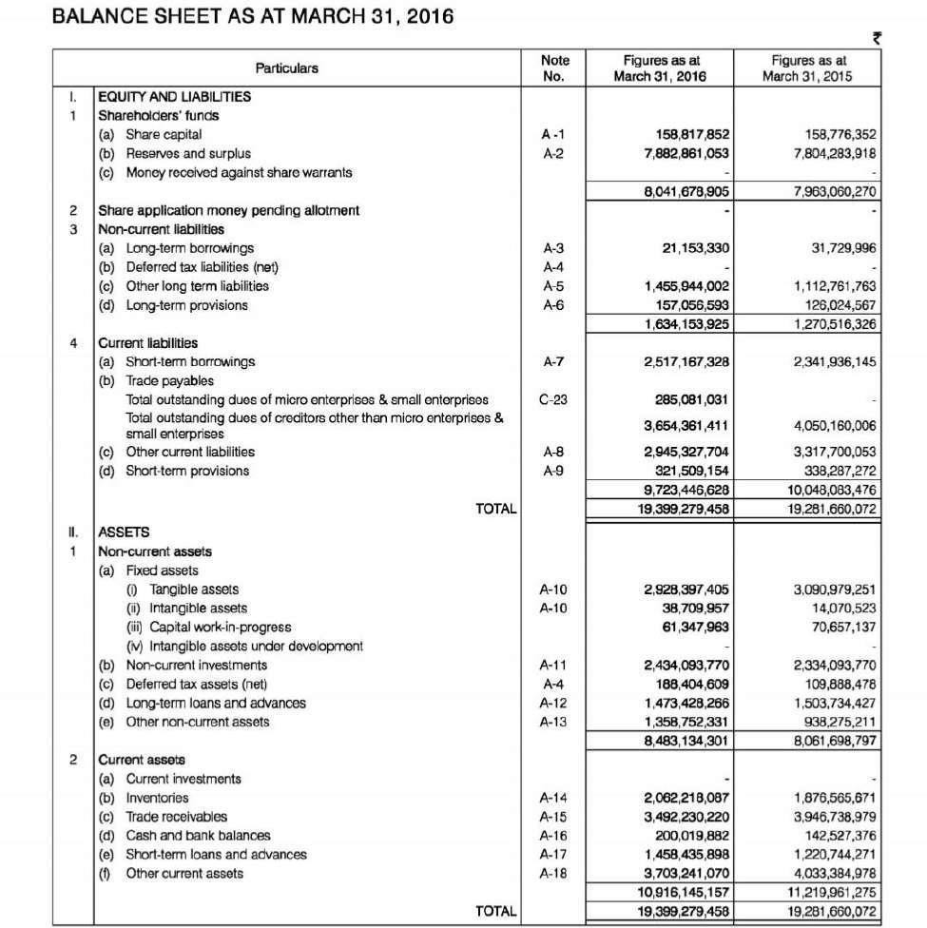
NOTE: Figures of Financial Year 2015-16 onwards are as per revised accounting standards (Ind AS) and for earlier Financial Years figures are as per old accounting standards (IGAAP). Previous years’ figures have been regrouped to make them comparable.

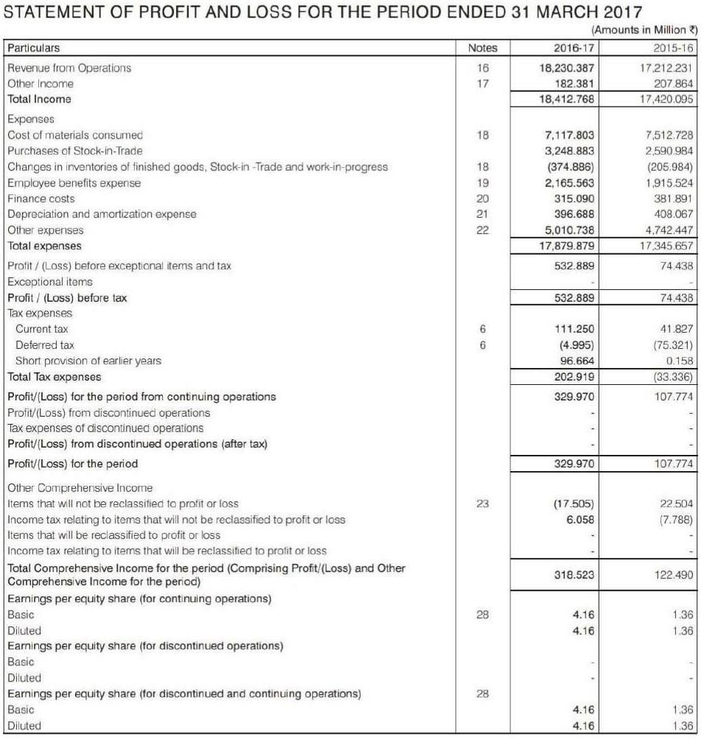
STATEMENT OF PROFIT & LOSS FOR THE YEAR 2016-17 & 2015-16 COMBINED

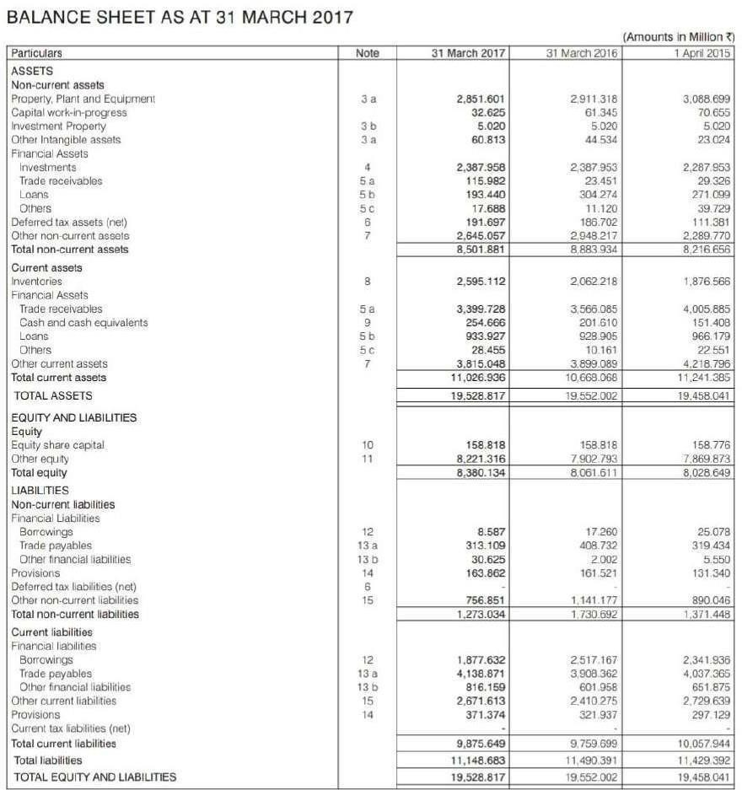

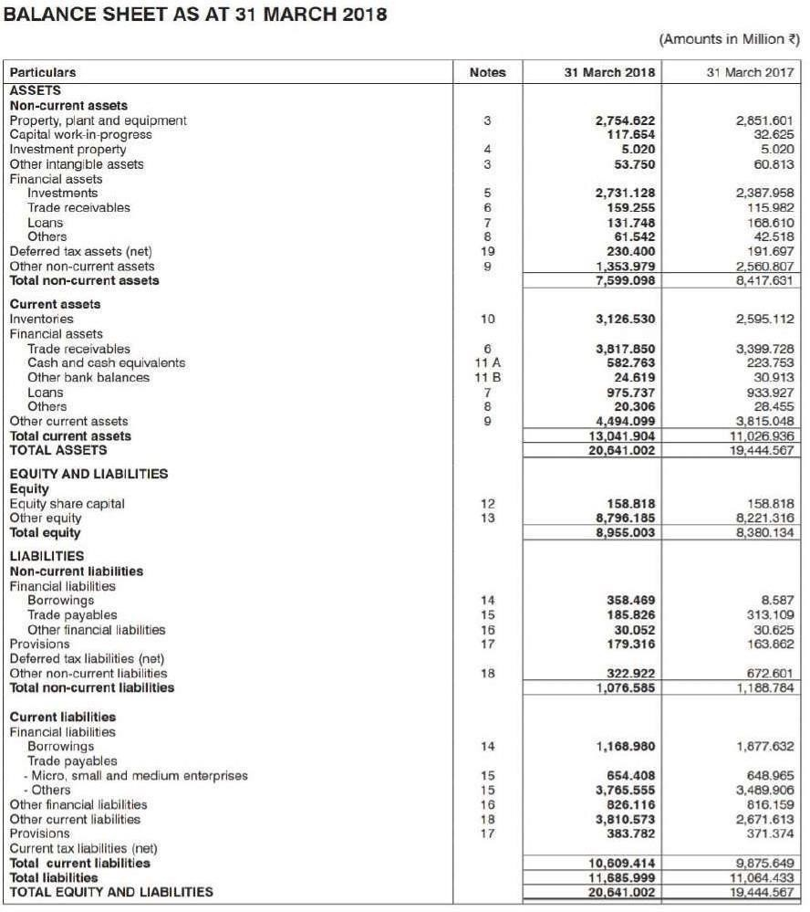

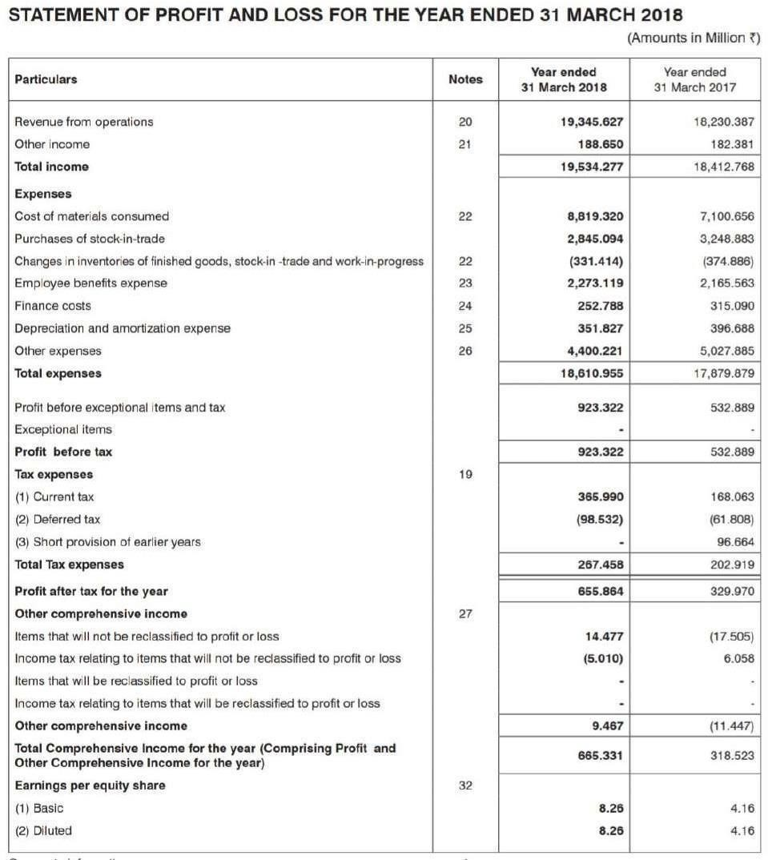

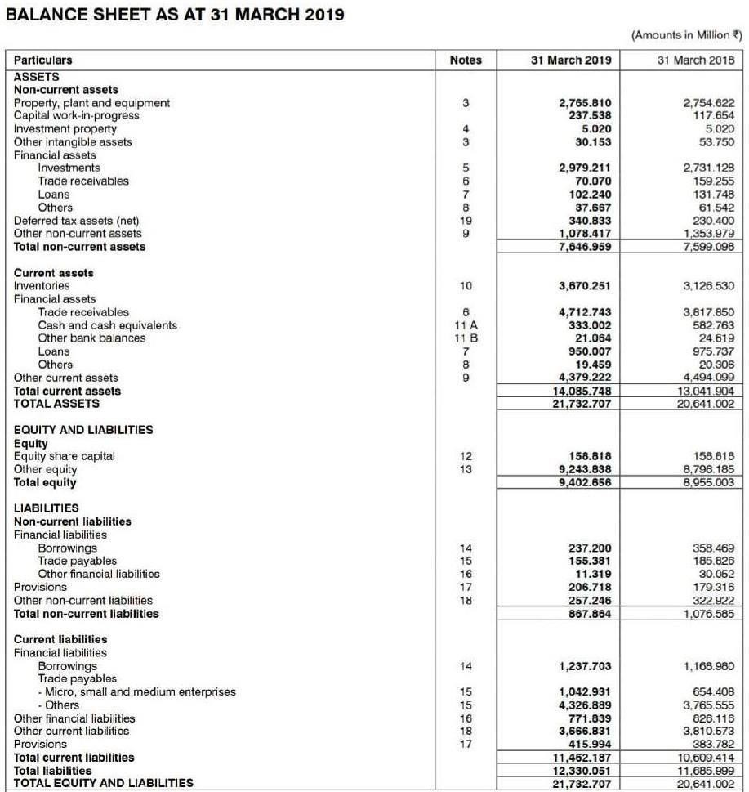

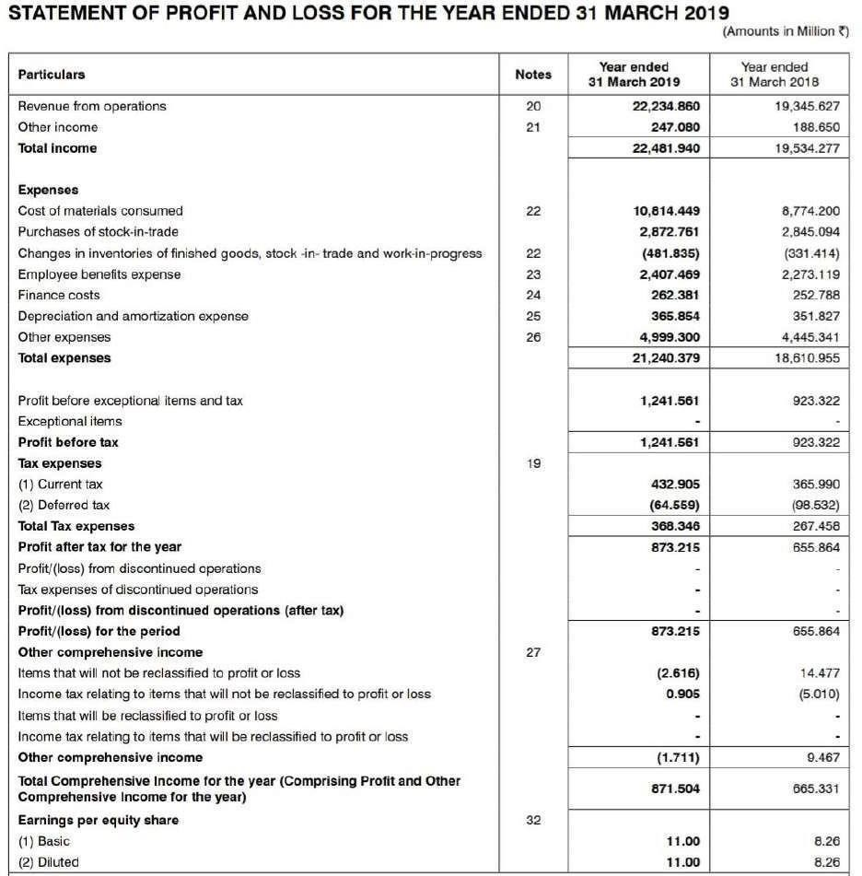

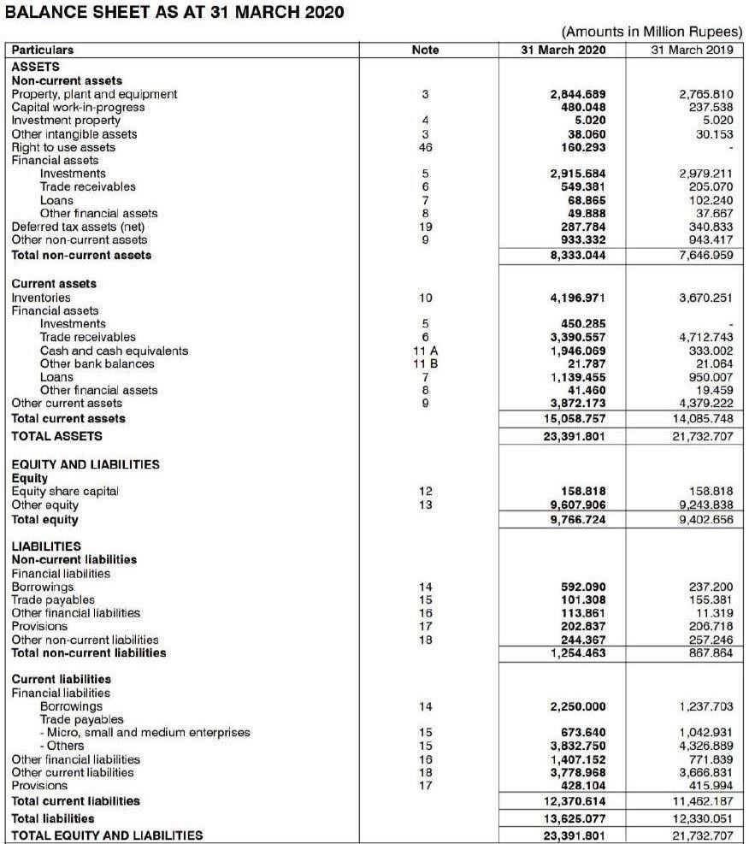

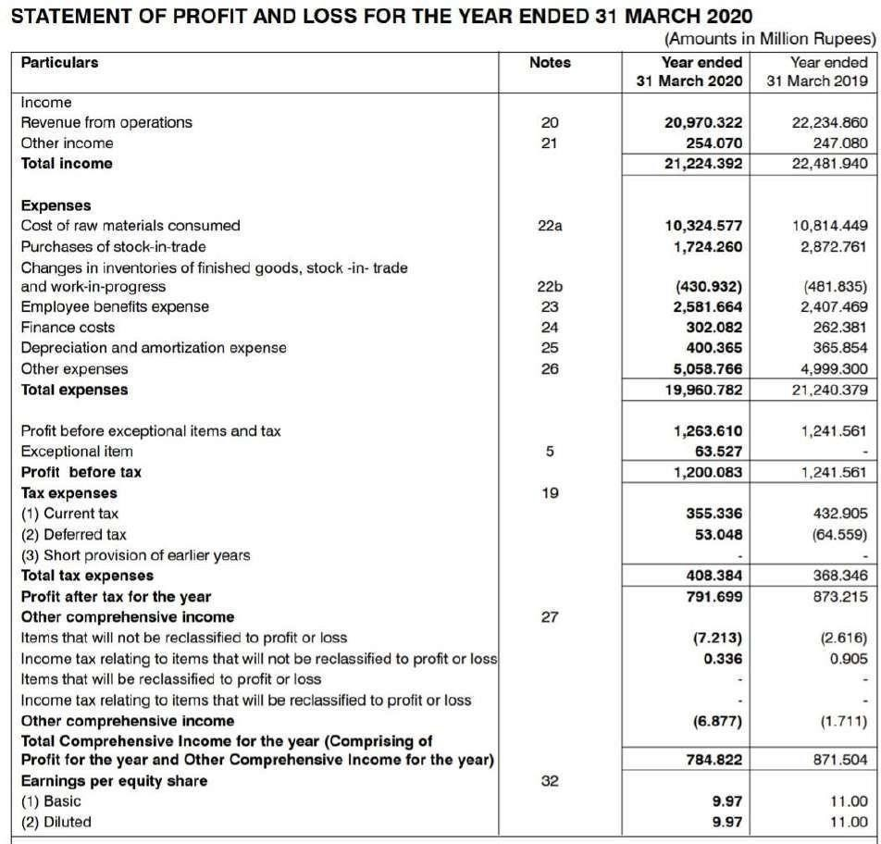

LEARNING OUTCOME

Through this study on working capital management with reference to Aaradhya Enterprises, Pune, I gained valuable insights into the practical functioning of financial management in a real-world business environment. The research deepened my understanding of key concepts such as current assets, current liabilities, inventory management, accounts receivable, and accounts payable. Observing the day-to-day financial practices of a small-to-medium enterprise highlighted the importance of maintaining liquidity and ensuring a smooth cash flow to meet operational needs. One of the major takeaways was learning about the challenges businesses face in managing working capital—particularly issues related to delayed customer payments and the need for balancing payables and receivables effectively.

The interview with the owner provided a first-hand view of how strategic decisions are made in areas such as credit terms, inventory control, and supplier negotiations. It also showed the increasing role of technology in financial management, especially the use of ERP systems for monitoring inventory and receivables. Additionally, this research helped me develop essential skills like data collection, interview techniques, ethical research conduct, and critical analysis. Overall, the study enhanced my ability to connect theoretical knowledge with practical applications and improved my strategic thinking in terms of how efficient working capital management contributes to overall business sustainability and growth.

REFERENCES

Books:
- Financial Management, Theory and Practice 10th Edition by Prasanna Chandra.
- Financial Management for CA Intermediate by Institute of Chartered Accountants of India.
- Financial Analysis & Control for MBA by Nirali Prakashan.

Websites:

www.moneycontrol.com https://m.economictimes.com https://www.business-standard.com https://economictimes.indiatimes.com https://www.alphagamma.eu https://financialservices.gov.in https://corporatefinanceinstitute.com https://www.financialexpress.com

